

The uses of this software include:

• What type of software development process is applied.

ANS: We are using Agile.

• Why did you choose this type (Waterfall or Agile)?

ANS: Because adopting Agile allows Amazon to provide better software and save a lot of money, the Agile model also allows customers to respond to the changing market and customer needs by constantly changing the product development, so that the product will not become obsolete after launch.

• Potential software (i.e., target market))

The main market of our shopping online is customers and suppliers.

Development process

This project focuses on facilitating the online shopping experience. Most of the functional requirements are about browsing and maintaining the product catalog, and placing and processing purchase orders.

In terms of customers, what we need to do with this product is that when customers browse on the website Shopping Online, we will display the following functions:

Client:

Customers can do the following:

a) registered as a client

b) the login and logout

c) browse to support paging

d) a variety of products according to brand filter products

e) according to the price of product classification

f) choose a product and browse the detailed information

g) will products add to cart

h) browse the selected product in the shopping cart

I) change the number of items in the shopping cart

j) to retrieve items from a shopping cart

k) in the shopping cart

l) in the purchase of a selected product tracking page to browse the purchase order

m) click on the purchase order to browse the detailed information in the order details page n) according to the current and past purchase filter purchase order

o) to score and write after buying the product A brief review of the product was shipped

Suppliers can perform the following operations:

a) Browse the various products that support paging

b) according to the brand, the product name and product ID filtering products

c) choose a product and browse the detailed information on

d) in purchasing tracking page browsing all purchase orders

e) click a button to browse the detailed information of the purchase order

f), according to the deity are cancelled and past order filter purchase order

g) delivery of the purchase order

h) input purchase order number to view and handle purchase order

I) obtain the relevant sales within the specified period and sales analysis report on time

Graphical Abstract

### Customer operations

1. **Register as a customer and Login**

In login page, user who does not have an account can click ‘Sign Up’ button to enter the register page.

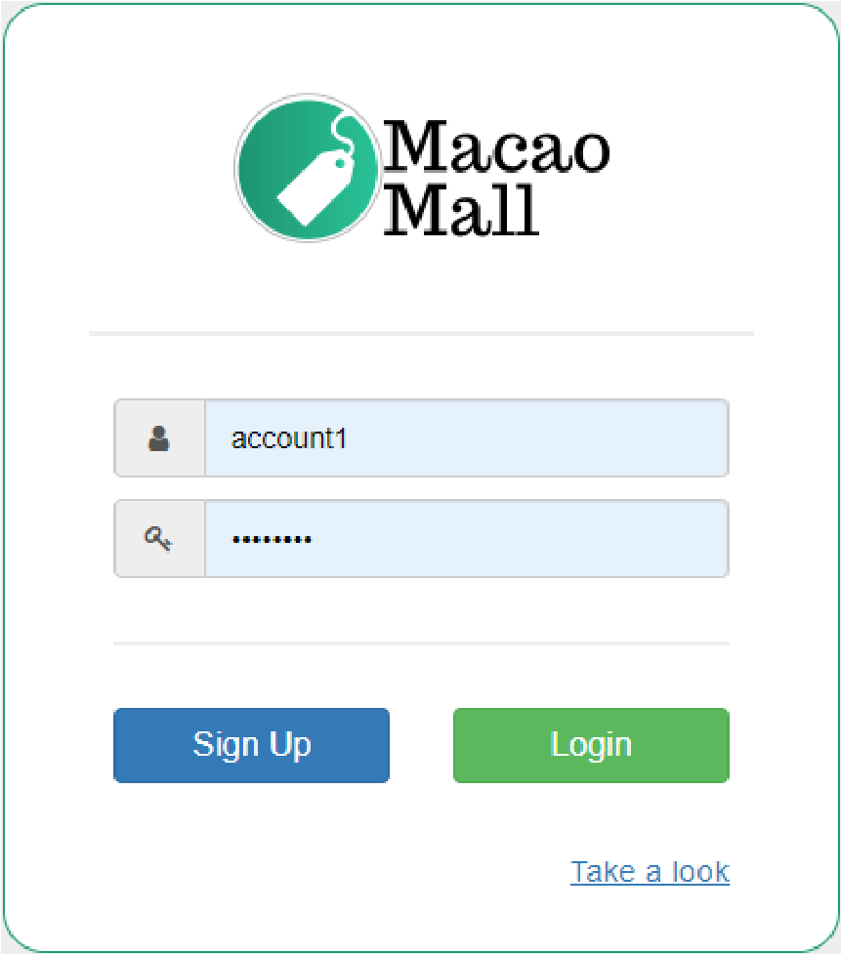

In register page, user is required to fill all the information including name, email address, password and shipping address.

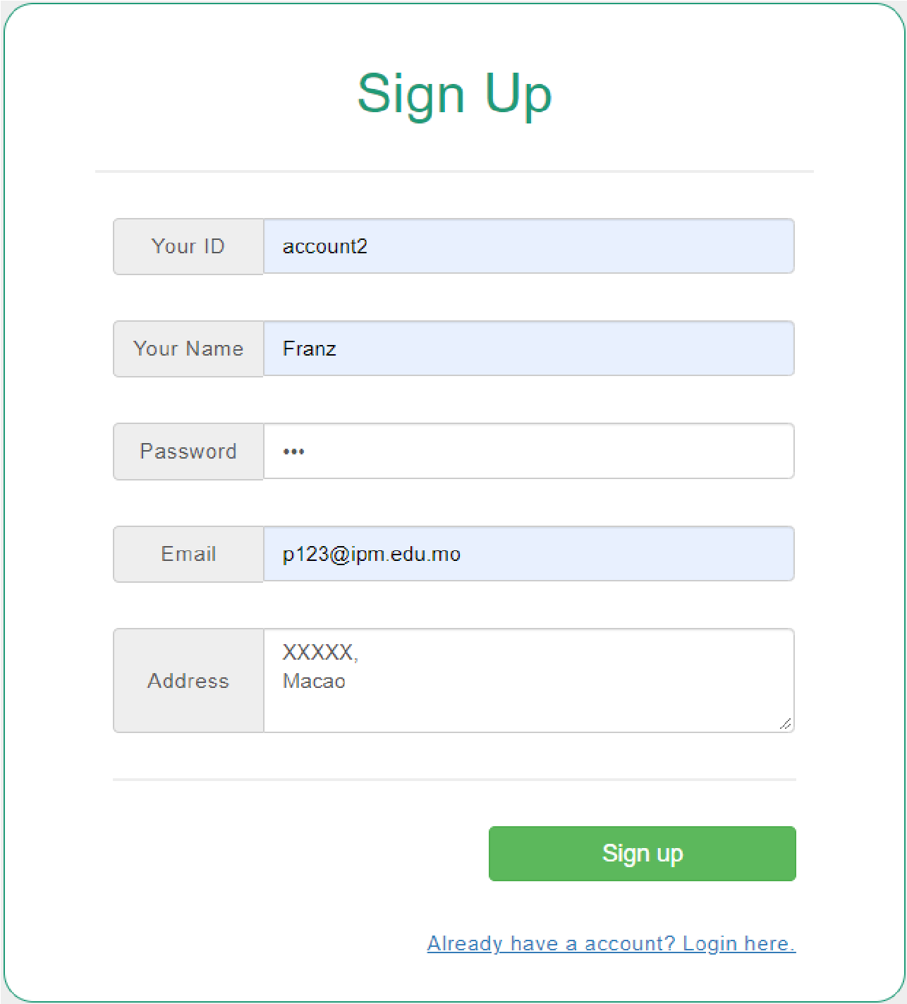

After clicking the sign-up button, a message will be shown, and the user will login automatically and be redirected to the product page.

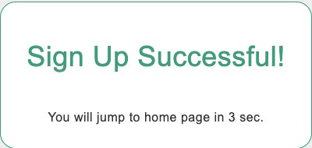

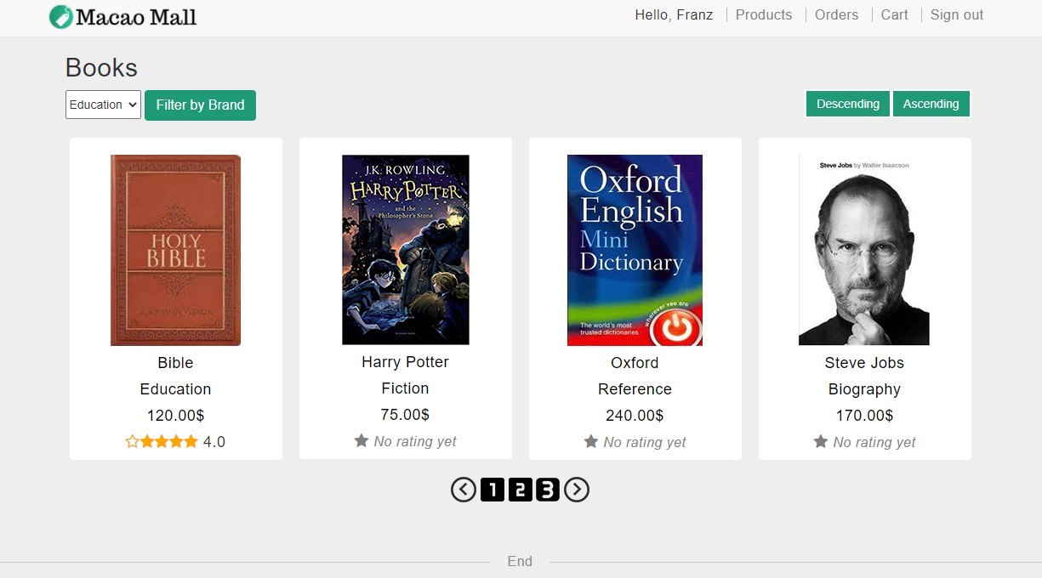

If the user signs up without filling all the information, a relevant error message will be shown.

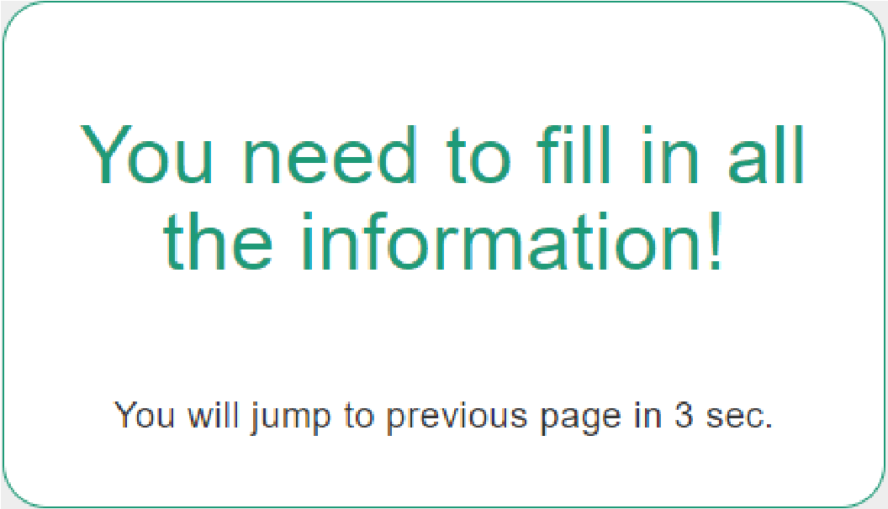

If the user signs up with an id that already exists, a relevant error message will be shown.

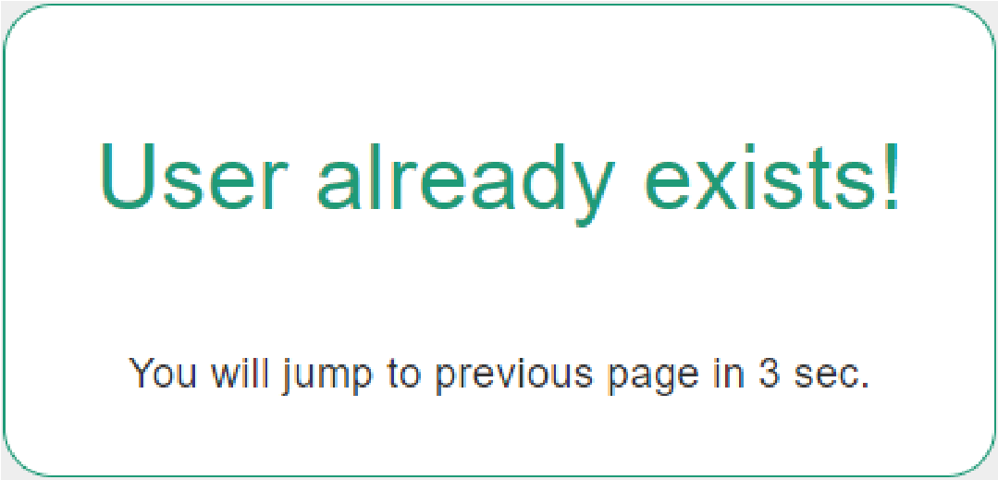

After login, user’s name will be shown in the navigation bar on the top of the page. User is also allowed to access cart and orders in the navigation bar after login. Navigation bar will only show the login link and product link to users who have not logged in.

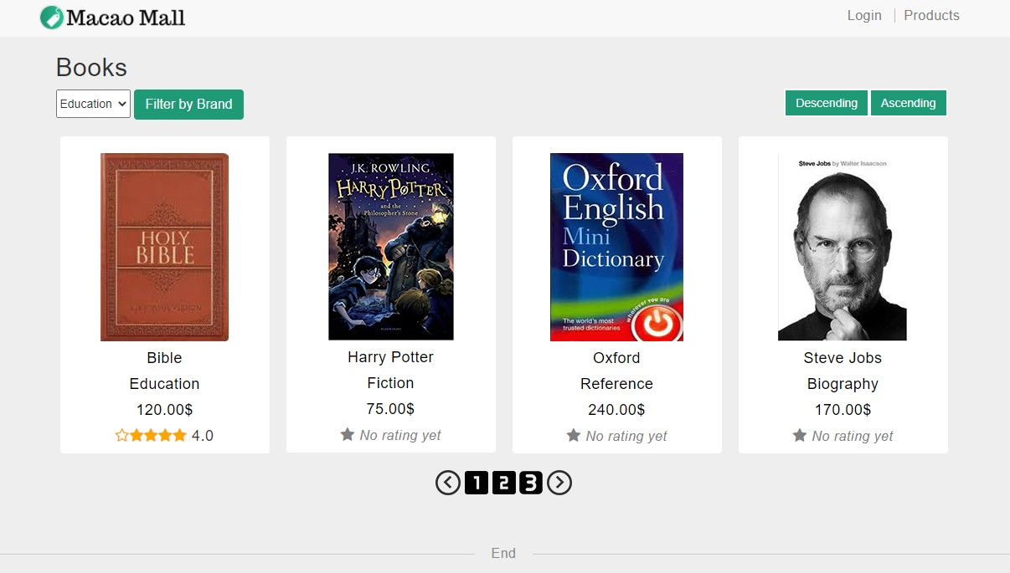

If a user who has not logged in try to access cart or order page by inputting the URL, an error message will be shown, and the user will be redirected to the login page.

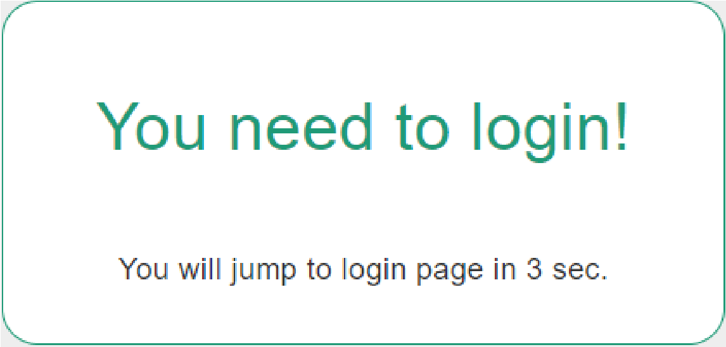

1. **Browse the products with paging supported**

The product list shows the basic information of the products (product name, brand, price and a thumbnail image), and its rating if available.

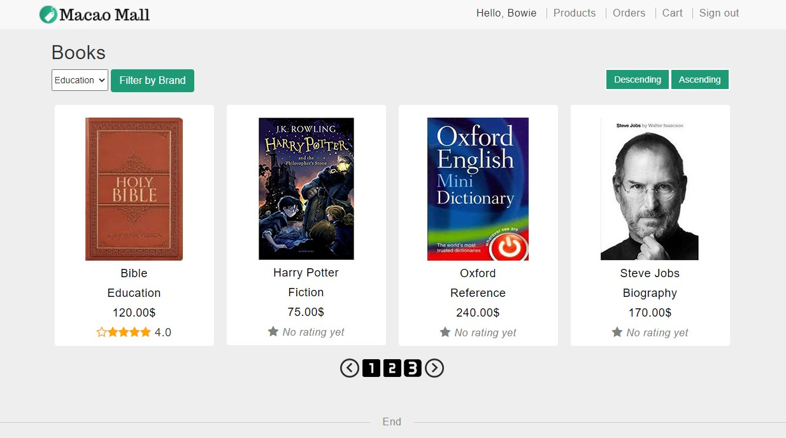

1. **Filter the products by brand**

Choose a brand, e.g. Biography and press the button to filter products belonging to a particular brand.

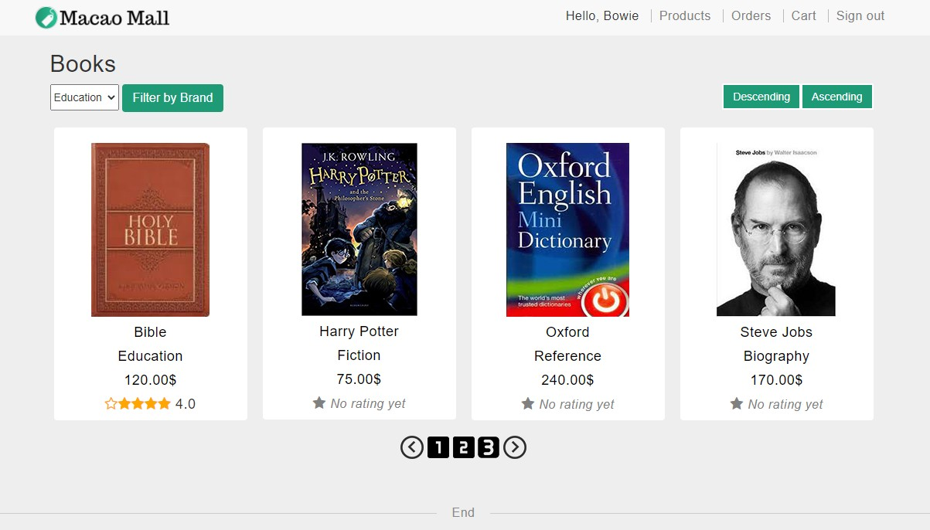

At the page with the filtered result, it will display a button (List All) to go back to the main page to list all the products.

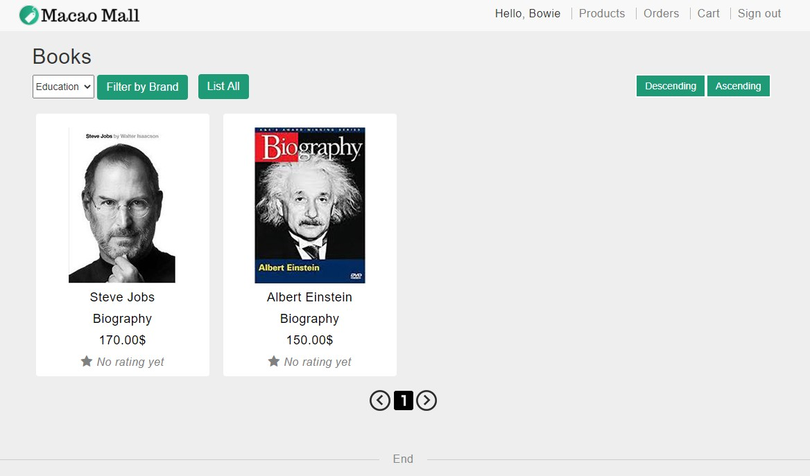

1. **Sort the products by price**

Users can click either “Ascending” or “Descending” button to sort the price accordingly.

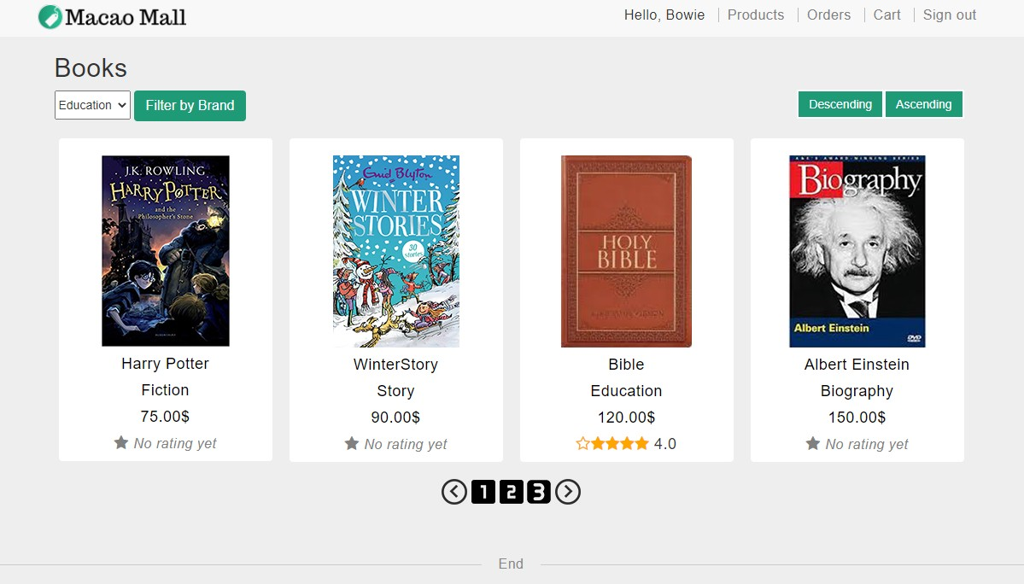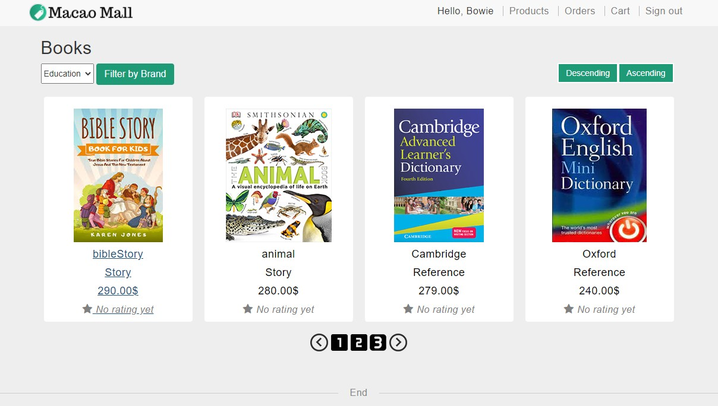

1. **Select a product and browse its detail**

When users want to see the details of a product, they just need to click on the image.



The detail page will display additional information of the product, including author, number of pages, publisher, and the customers review, if any.

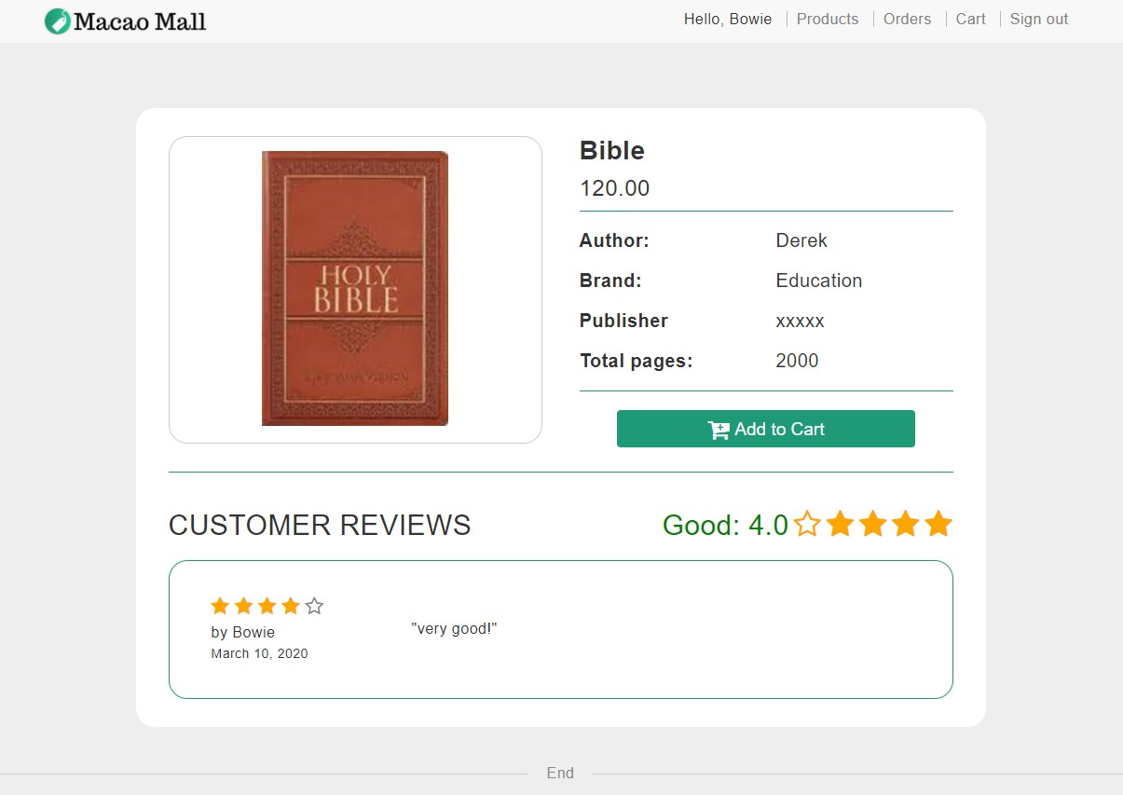

1. **Add a product to the shopping cart**

User can add a product to the cart by clicking ‘add-to-cart’ button in the product detail page.

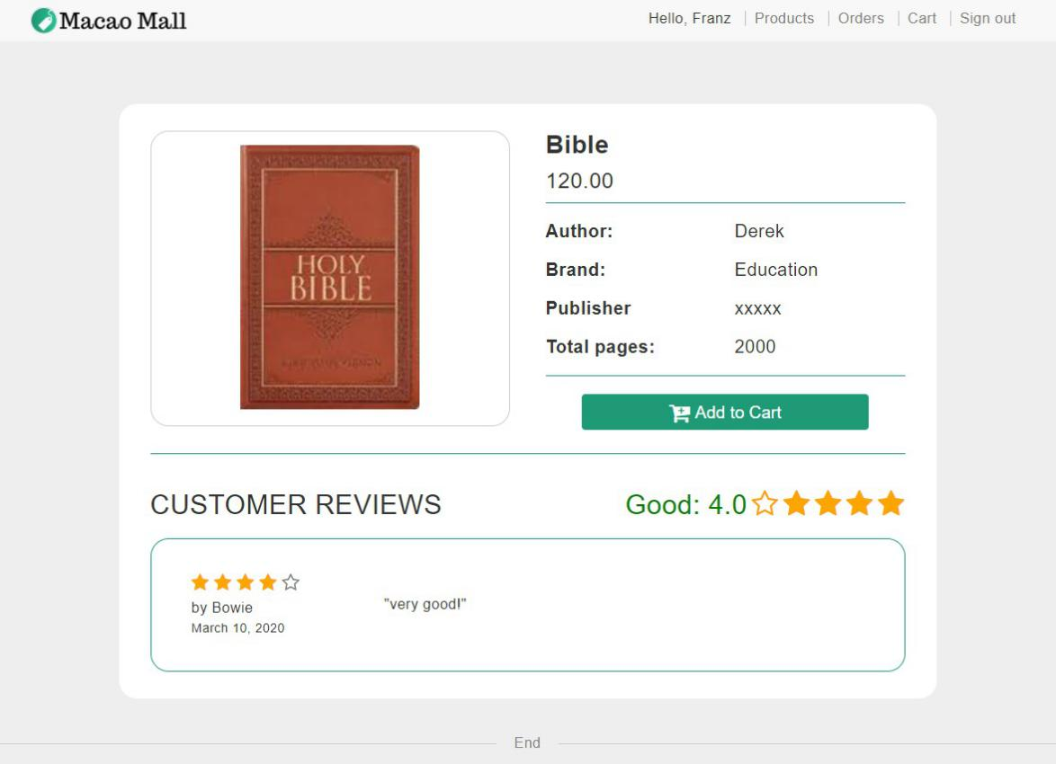

After clicking the button, the page will be refreshed and show that the product is already in cart.

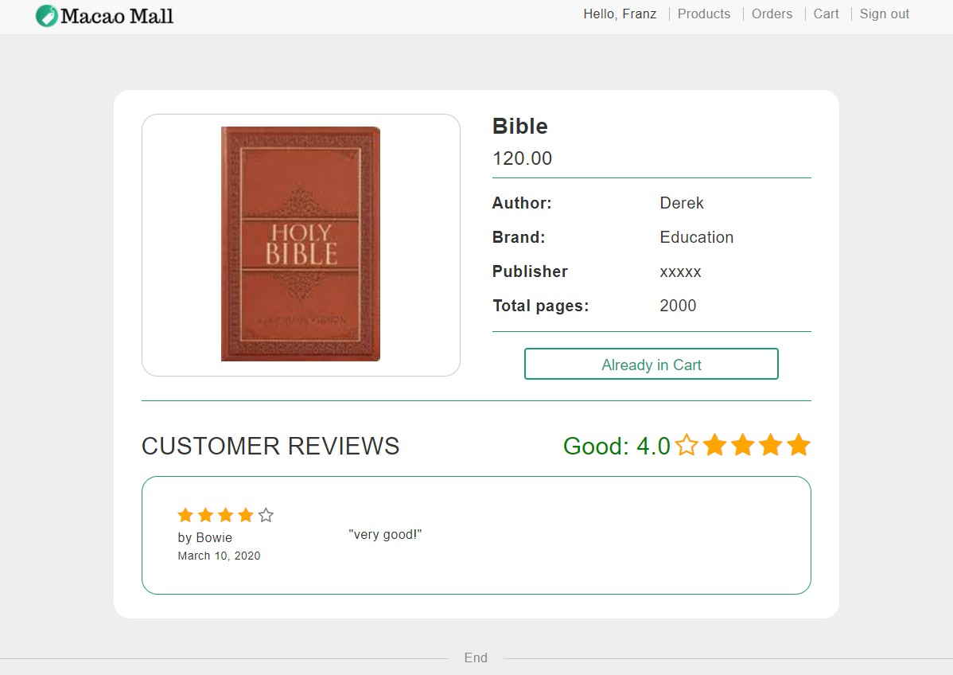

In the cart page, the product exists, and quantity is set to 1.

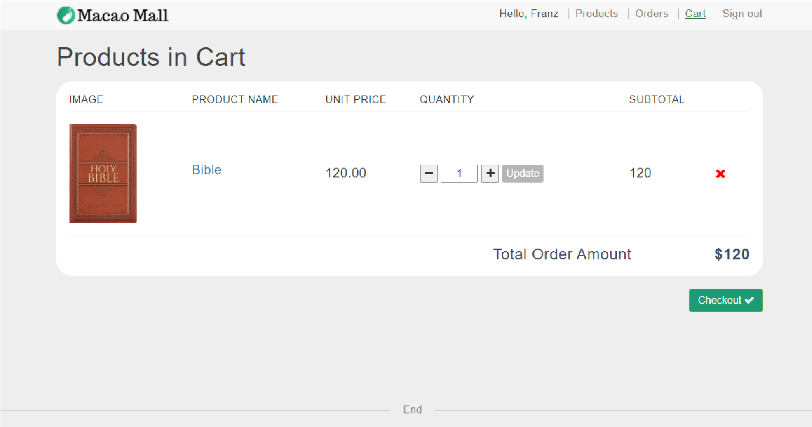

1. **Browse the selected products in the shopping cart**

Cart page lists the product name, price and the quantity of each product and the total amount. Users can also access the product detail page of a product by clicking the image or name of the product.

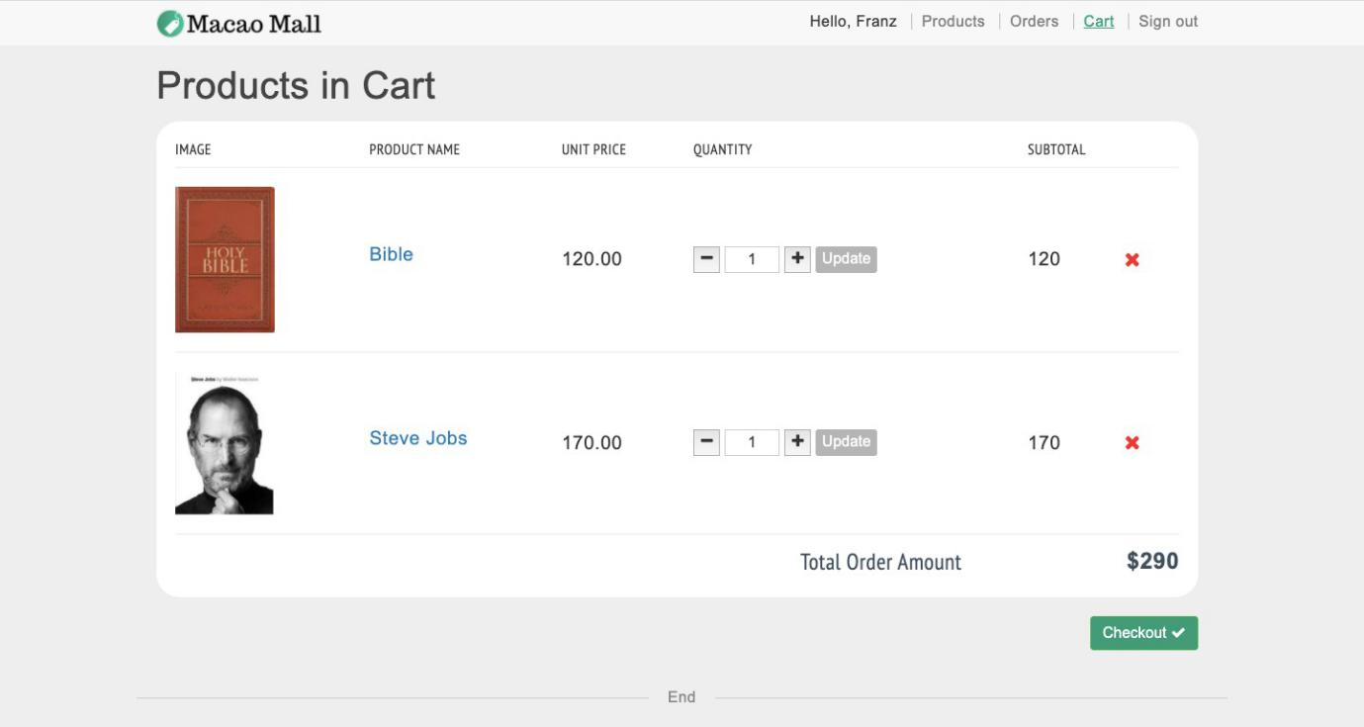

After clicking the image or name of product, user is redirected to the product detail page.



1. **Change quantity of an item in the shopping cart**

Users can change the quantity by clicking ‘-’ or ‘+’ button or input a number in the field directly.

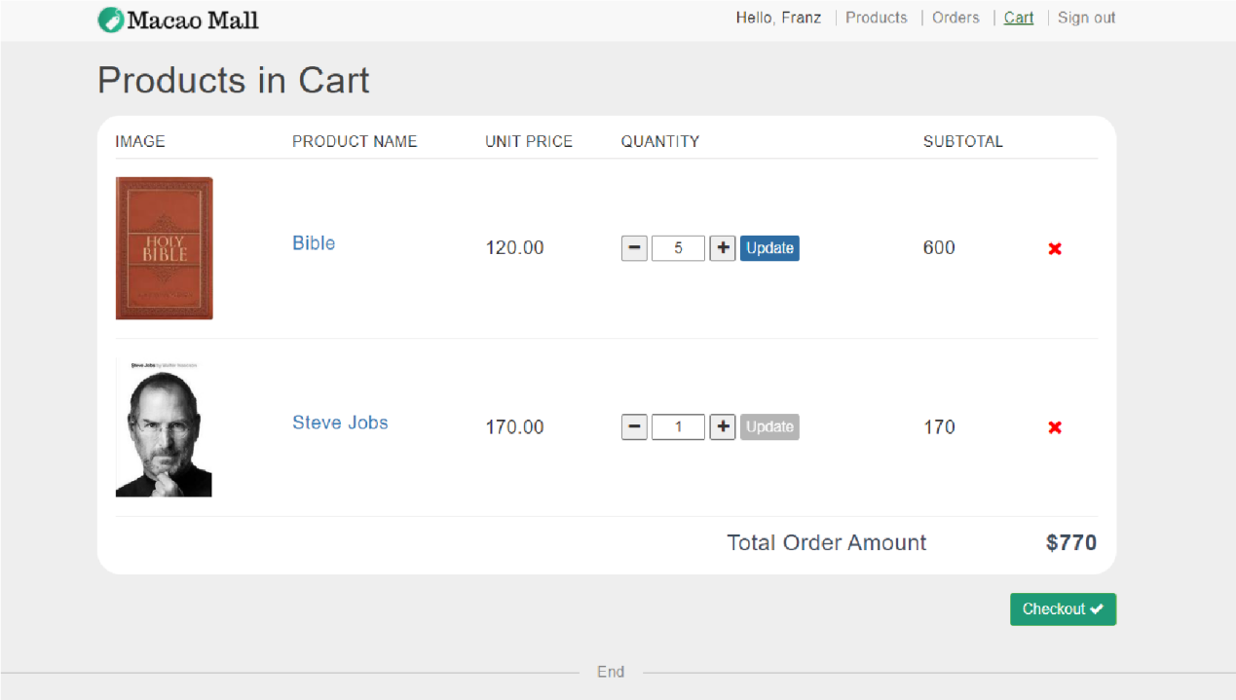

1. **Remove an item from the shopping cart**

Users can remove a product in the cart by clicking the ‘x’ button on the right.

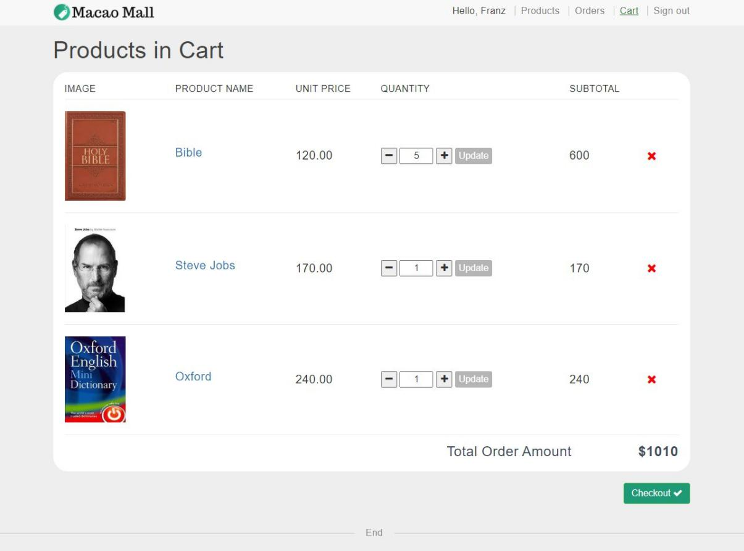

After clicking the button, the product is removed from the shopping cart.

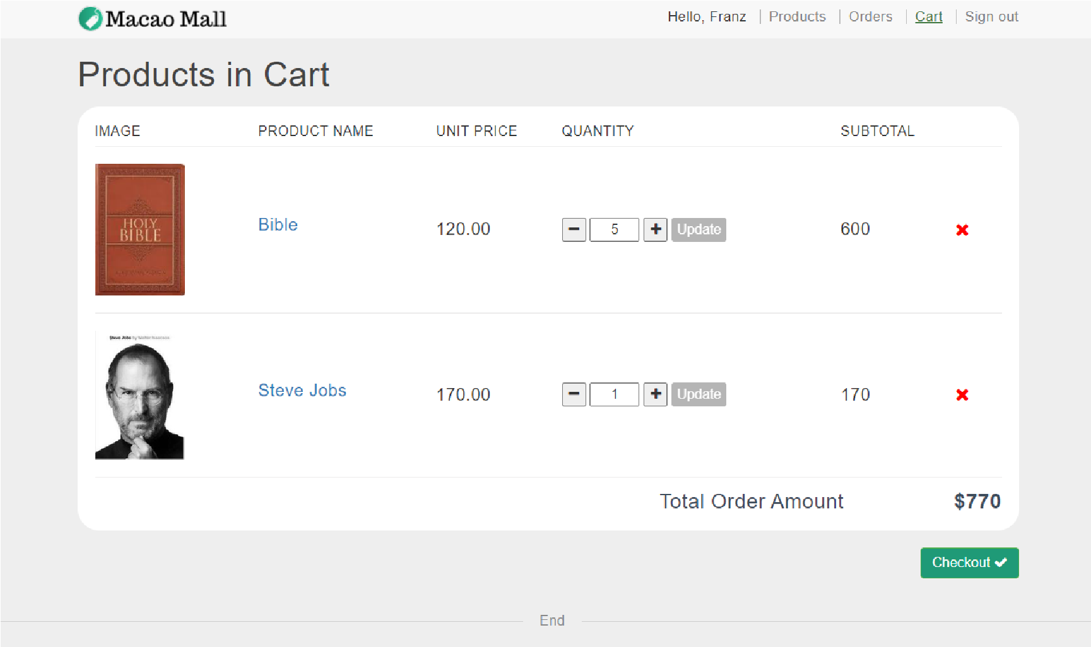

1. **Check out the selected products in the shopping cart**

Users can check out all the products in the cart by clicking ‘checkout’ button.

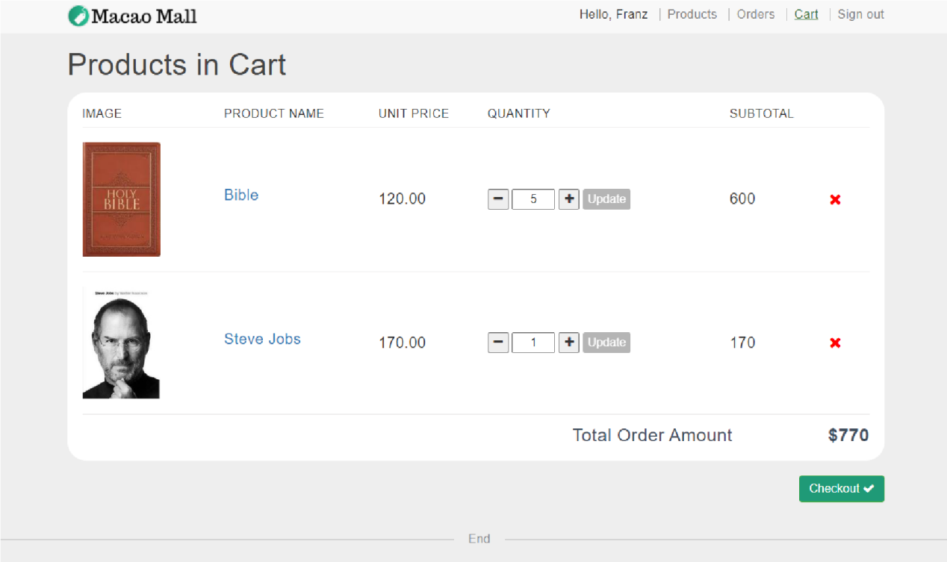

After clicking the button, a new order will be created with a unique number. Users will be redirected to the order detail page of the newly created order.

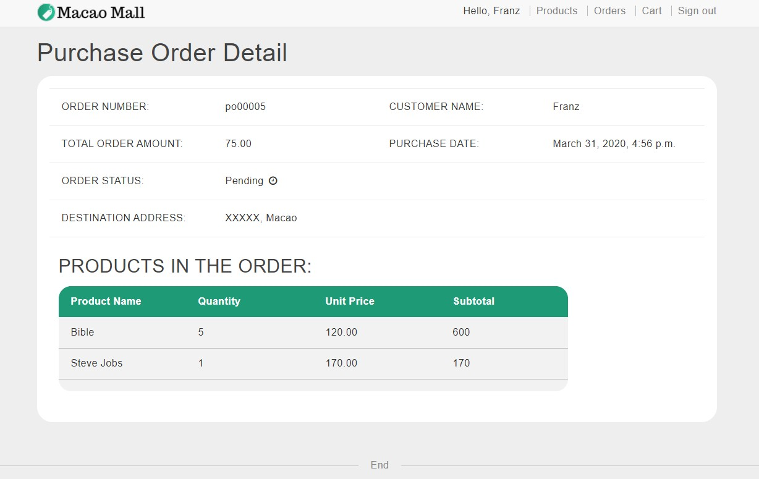

Cart is cleared after the purchase order is generated.

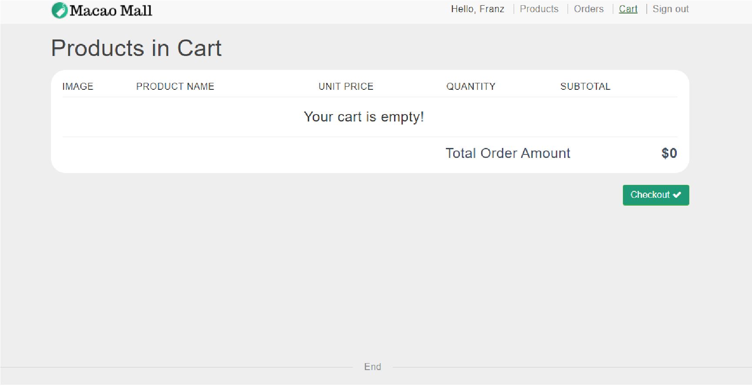

1. **Browse purchase orders in purchase tracking page**

The purchase tracking page shows all the orders that are placed by the customers, with the

P.O. number, the purchase date, the total order amount and the purchase order status of each order in reverse chronological order of purchase date. Customers can access the detail page of each order by clicking the order number or detail link shown on the right.

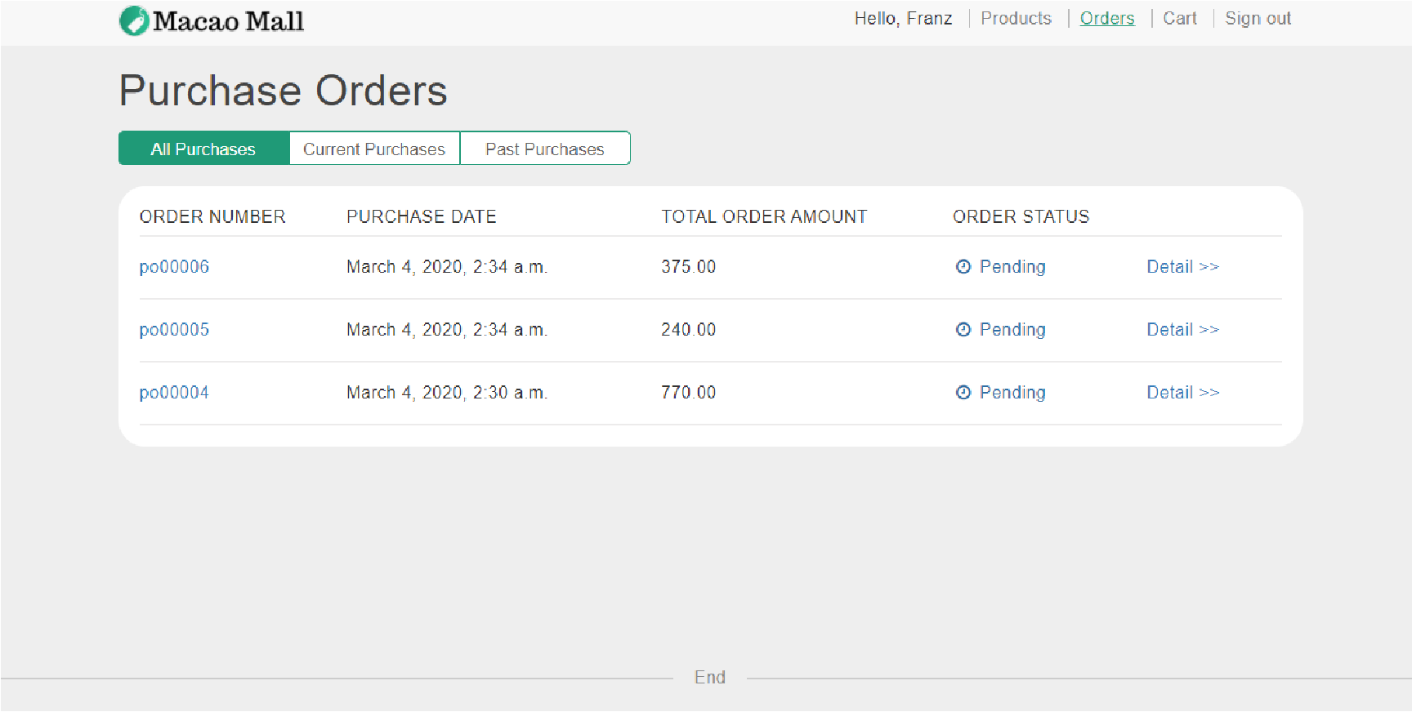

1. **Browse the details in the order detail page**

After clicking, users will be redirected to the order detail page of the selected order.



The purchase order detail page shows all the information of an order and each product in the order.

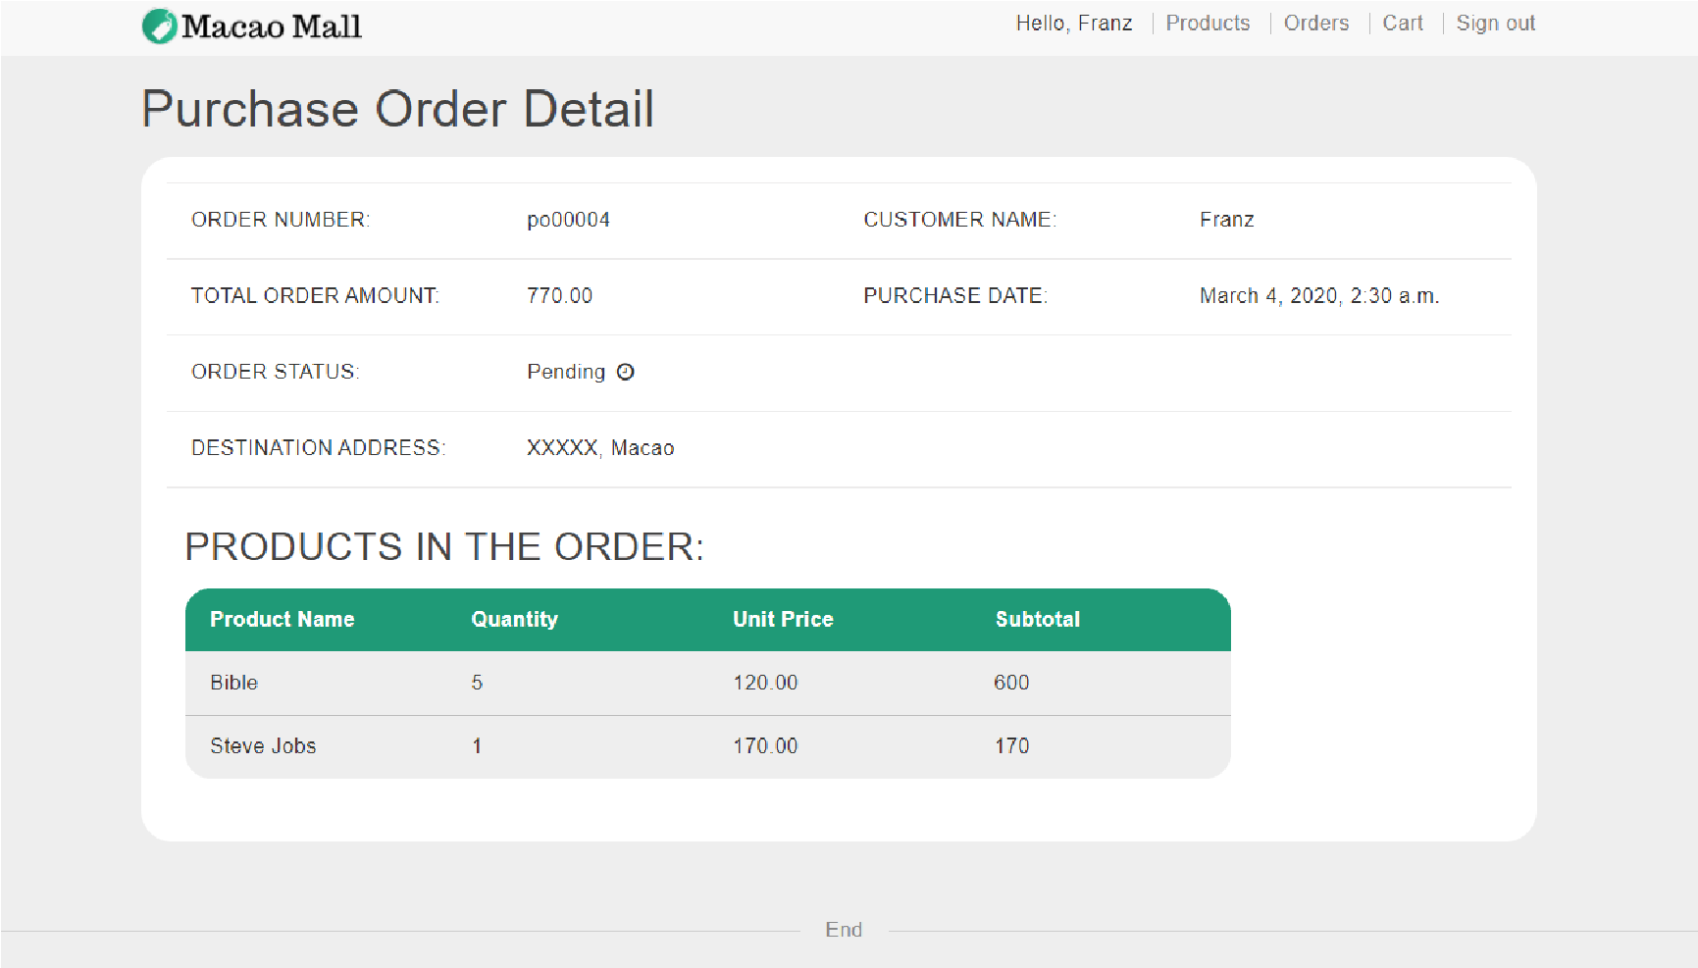

If an order is shipped, the shipment date will be shown.

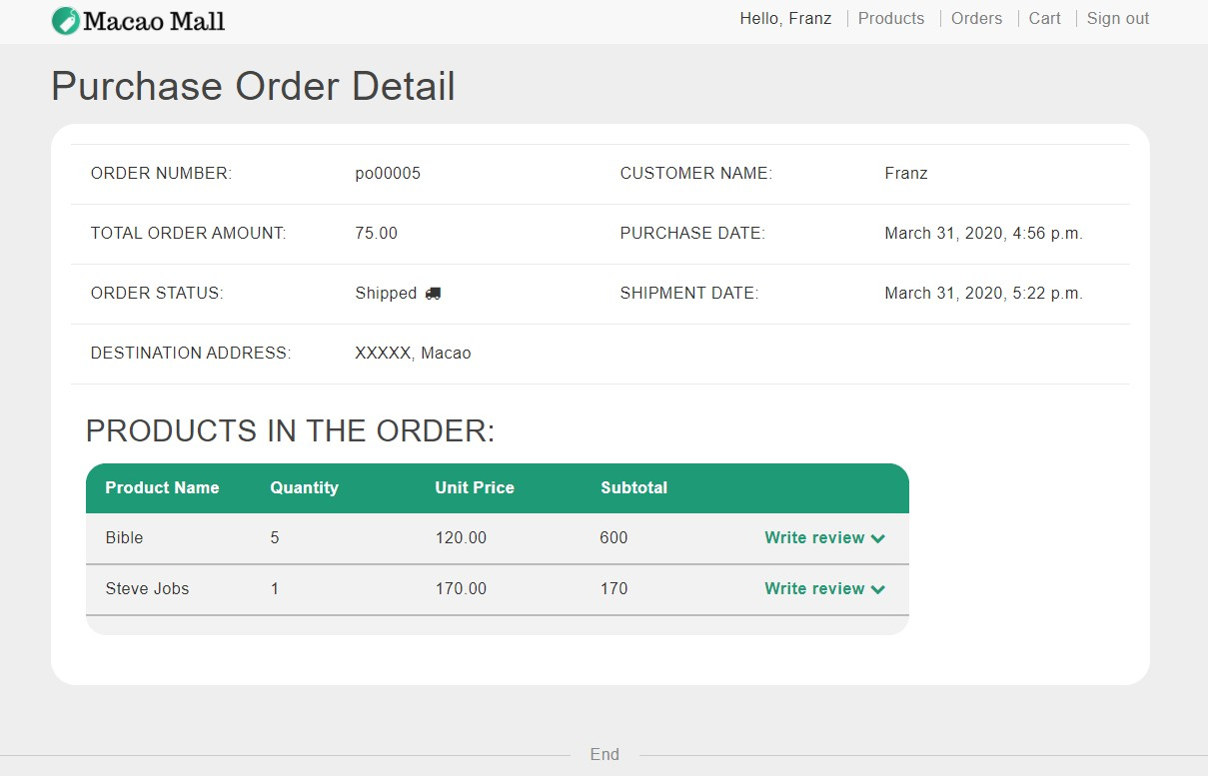

If an order is cancelled, the page shows the order cancel date and who cancelled the order.

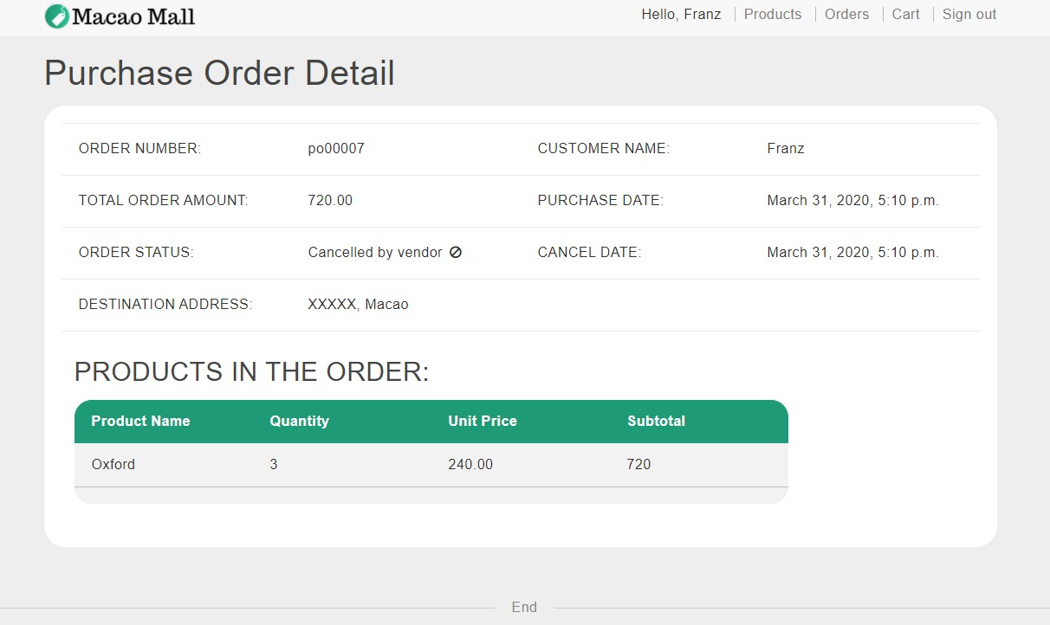

1. **Filter the purchase orders by current purchases and past purchases**

Customers can filter the orders in two ways: (1) ‘current purchases’ with status ‘pending’ and ‘hold’, (2) ‘past purchases’ with status ‘shipped’ and ‘cancelled’.

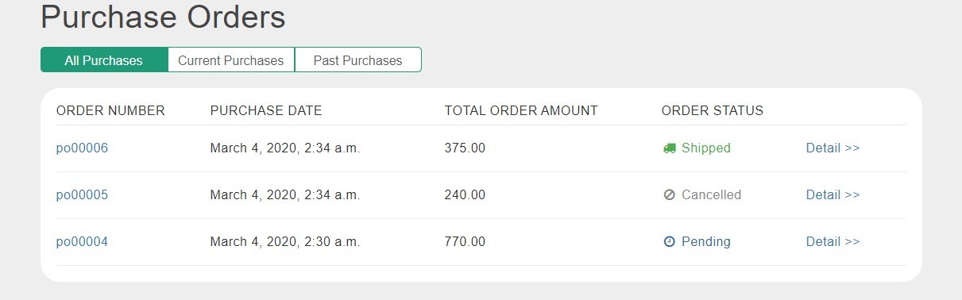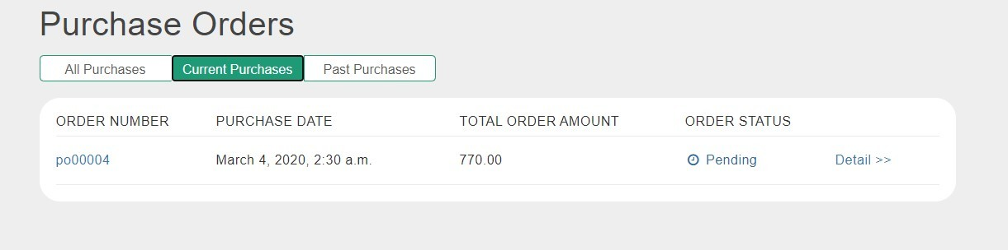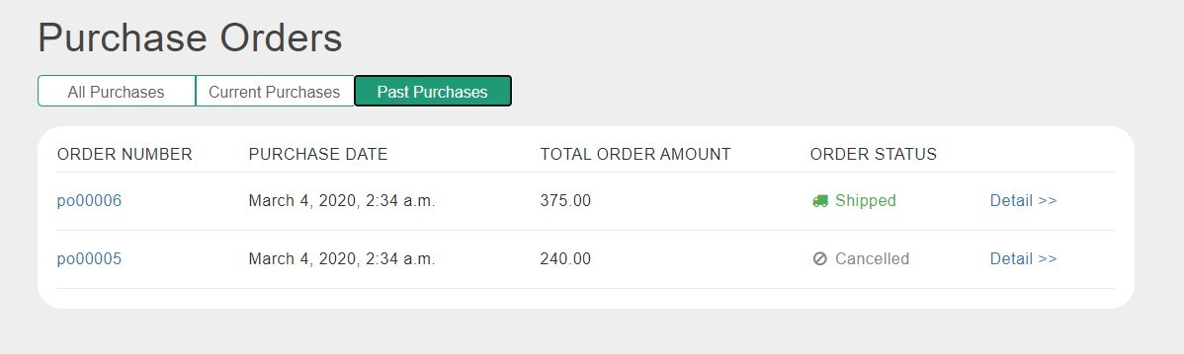

1. **Rating and reviews**

After an order is shipped, user is allowed to review and rate each product once in an order, which means if a user bought a product more than once in different orders, the user can review and rate this product multiple times, but in different purchase orders. After an order is created, the status is “pending” and there is no button to write a review.

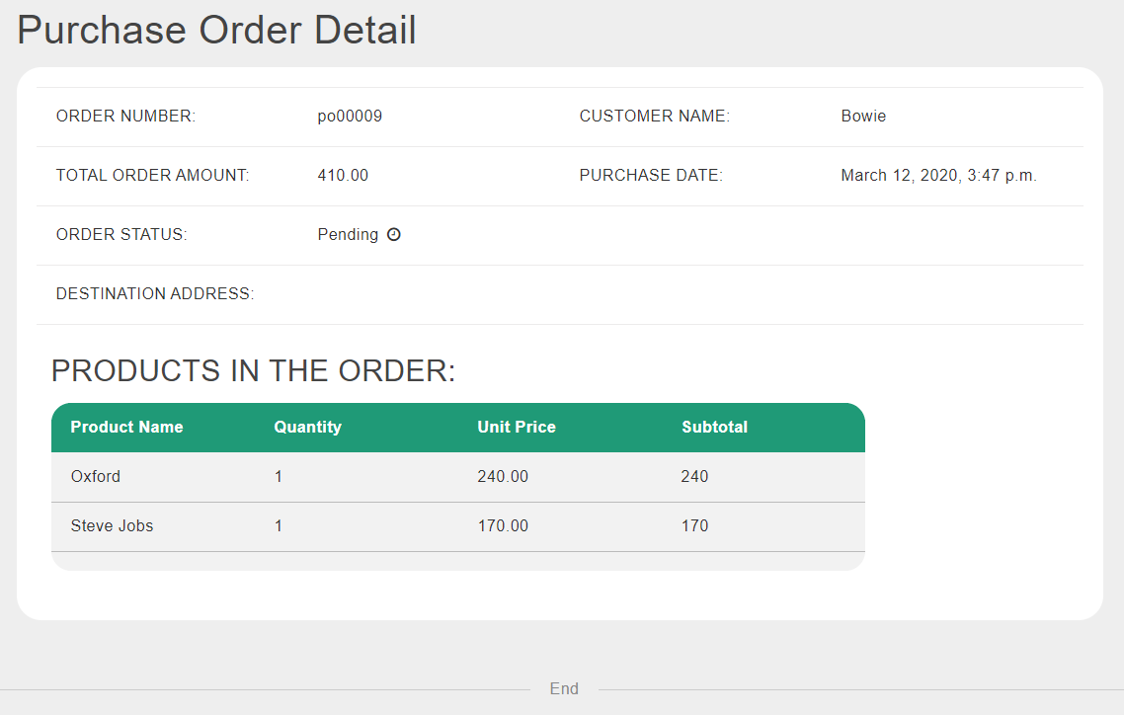

After an order is shipped, user is allowed to write review in the order detail page by clicking ‘Write review’.

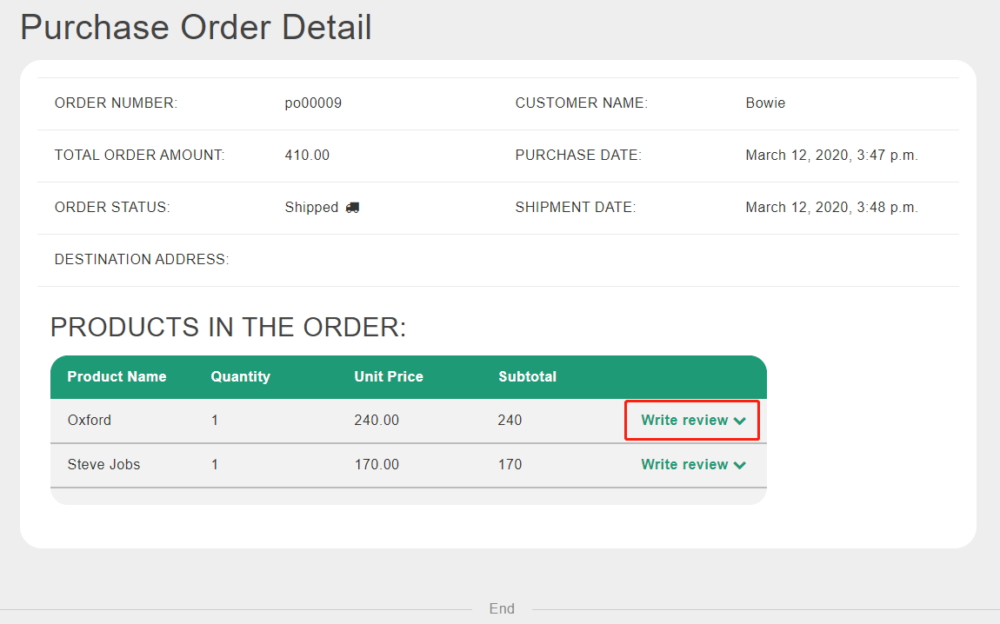

After clicking the button, a review form will be displayed under the product.

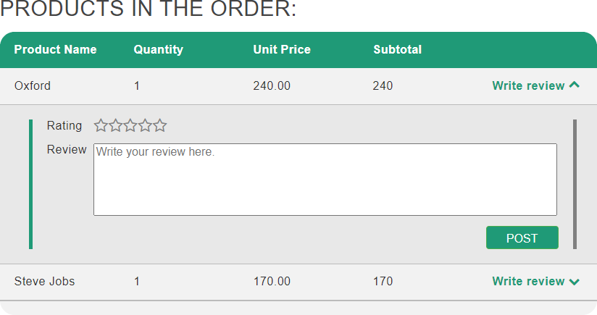

User can click the stars after ‘Rating’ to rate the product or type in review in the text area.

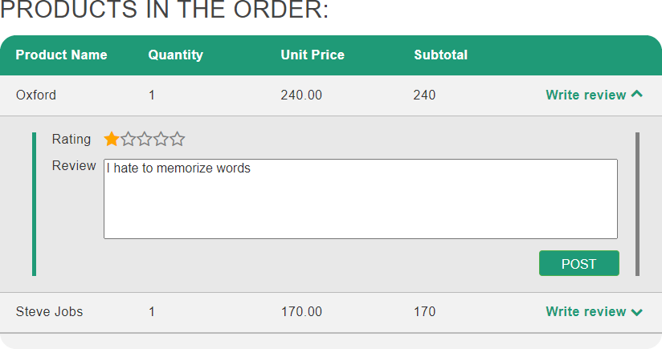

If user tries to post without rating, an alert message will be shown. But user is allowed to rate without filling in review.

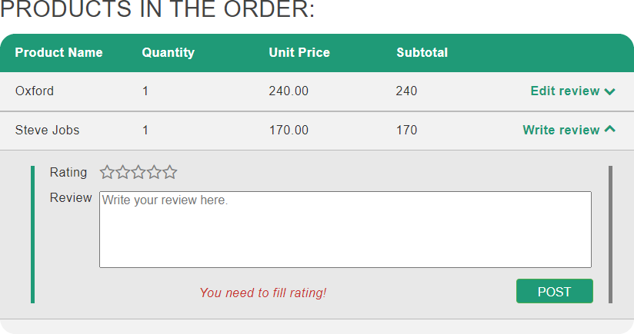

After a successful post, the rating and review will be posted. The ‘Write review’ button will be replaced by ‘Edit review’.

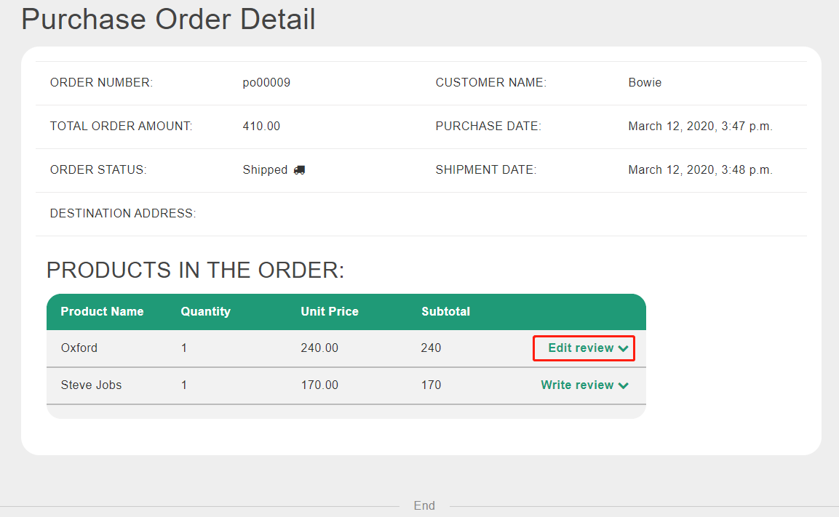

User can check and edit rating or review posted before. Without editing, the ‘UPDATE’ button is disabled.

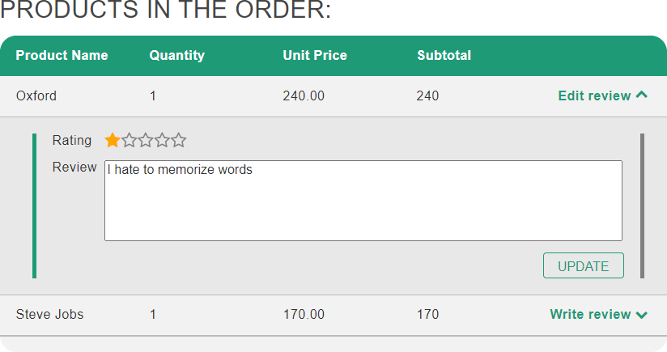

After editing rating or review, the ‘UPDATE’ button will be enabled.

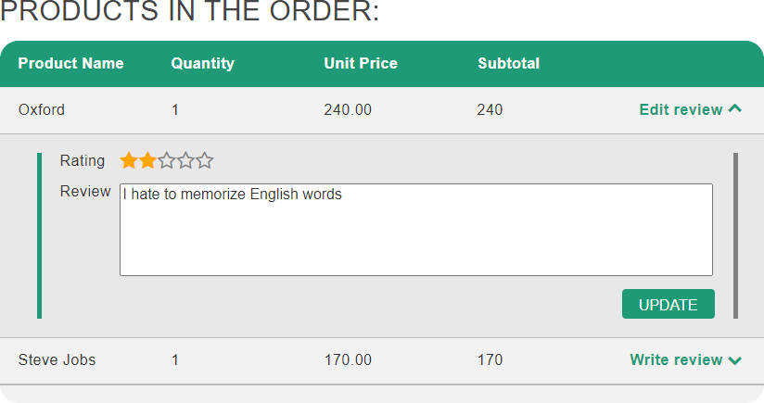

After clicking the button, the rating and review are successfully edited.

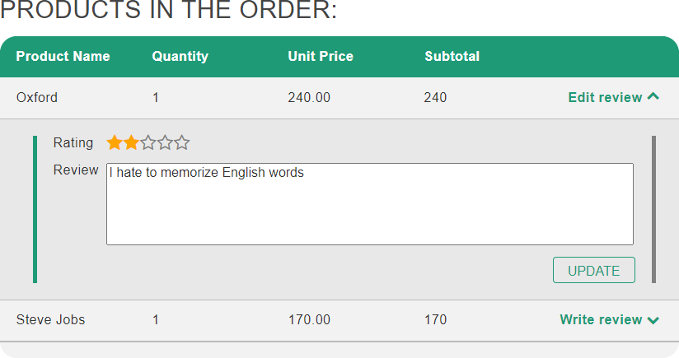

The product list page shows products with its average rating. If the rating of a product is less than 2.5, the rating stars of the product will be displayed in red to alert user. If a product has no rating, the line of rating will display ‘No rating yet’.

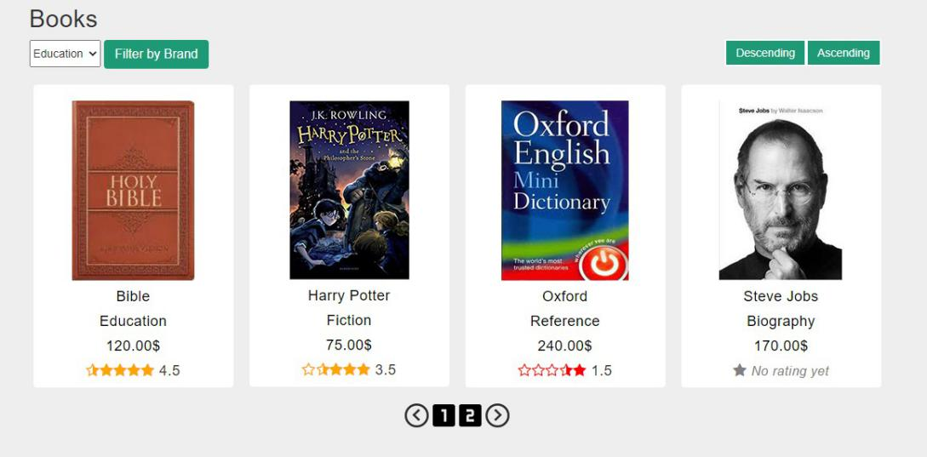

The reviews of product will be displayed under the product detail. It includes every review of this product as well as the average rating. Each review entry shows rating, reviewer name, review date and review content.

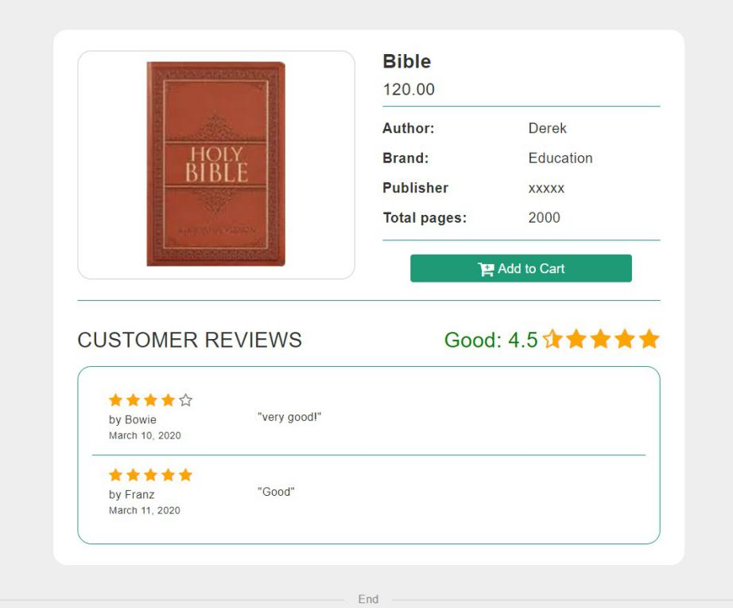

Empty review will be displayed as ‘The user did not fill in the review’. If the review has been edited, the review date part will show edited date.

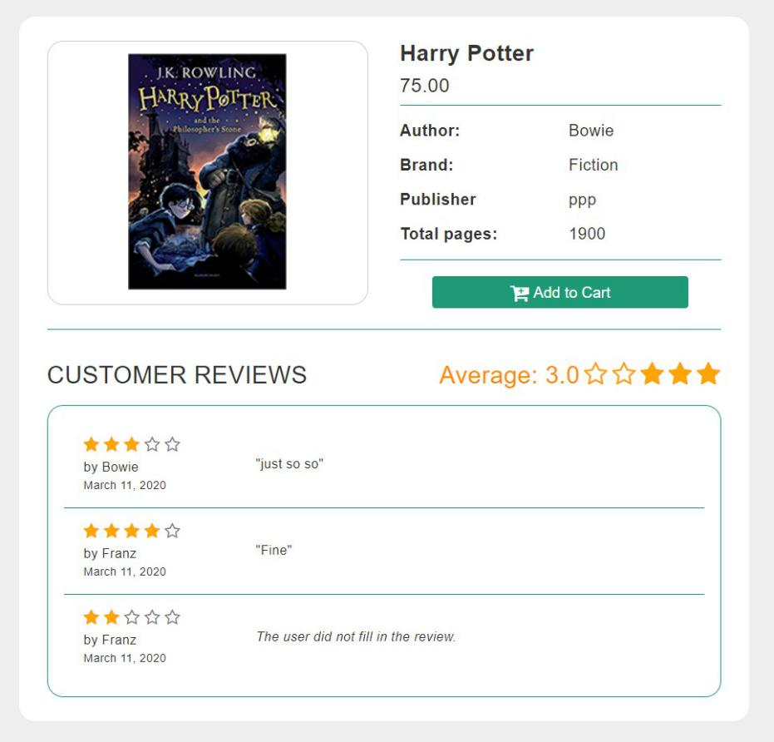

The average rating is shown on the top of the review part. If the average rating is less than 2.5, it will be displayed in red and marked as ‘Bad’. If the average rating is between 2.5 and 4, it will be displayed in orange and marked as ‘Average’. If the average rating is more than 4, it will be displayed in green and marked as ‘Good’.

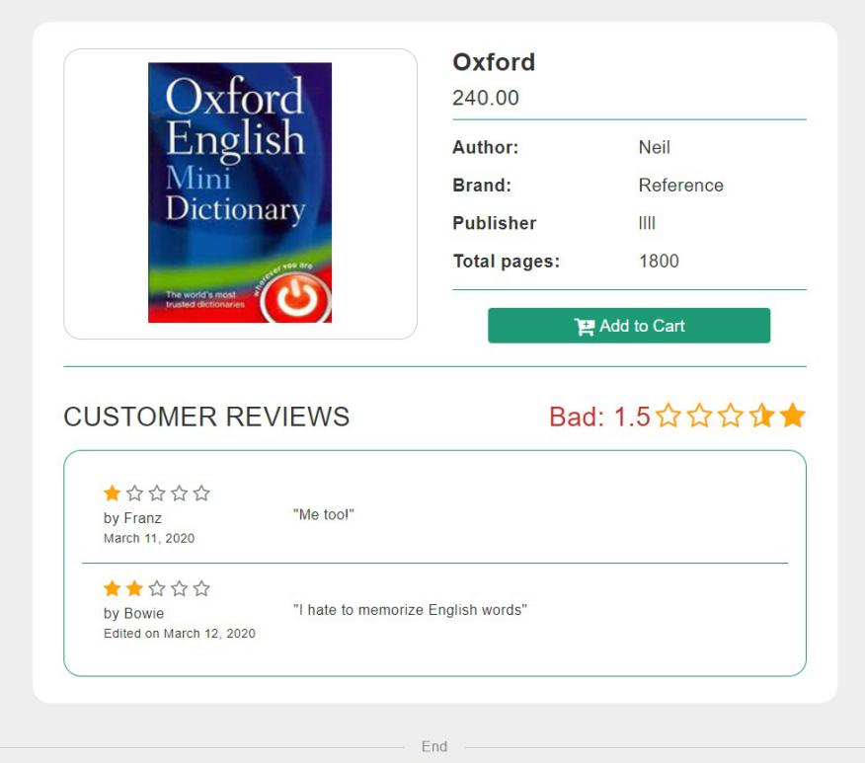

### Vendor operations

1. **Browse various products, with paging supported**

When logging into the vendor account, the shopping cart will be hidden from the home page. Instead, there will be an “Analysis” button to be discussed later.

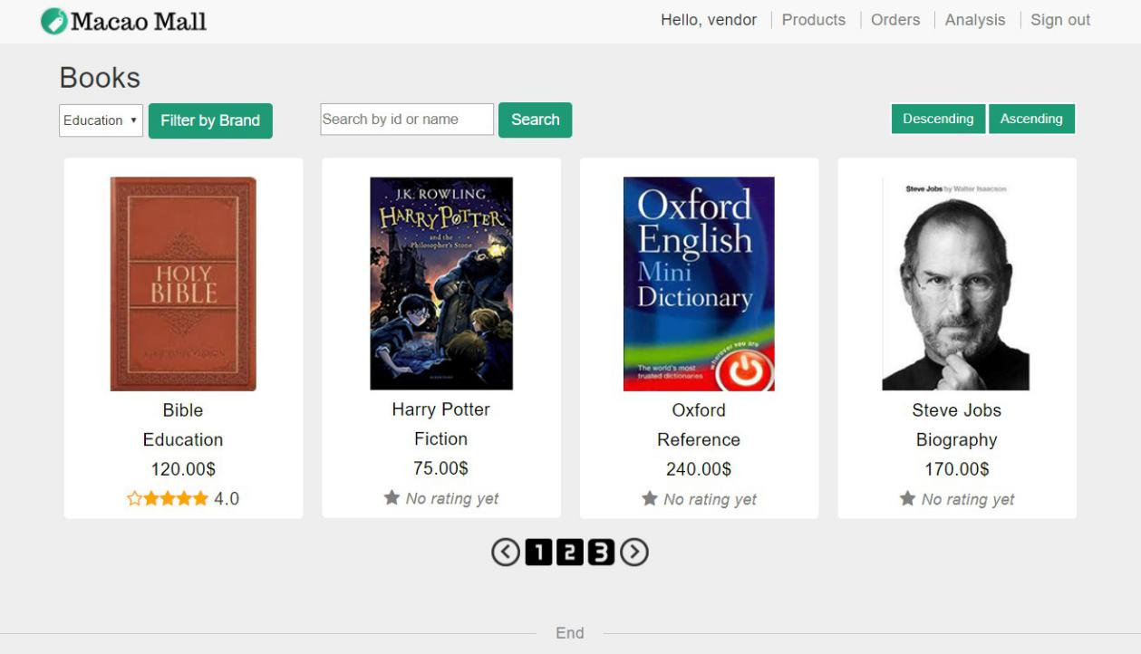

1. **Filter the product by brand, search by product names and product ID**

Vendor can search a product by keyword of the product.

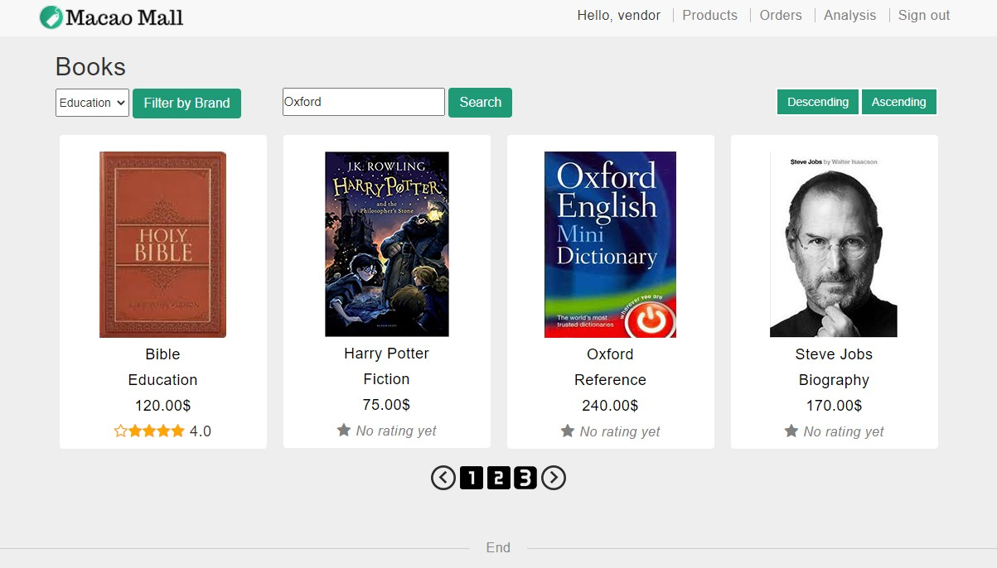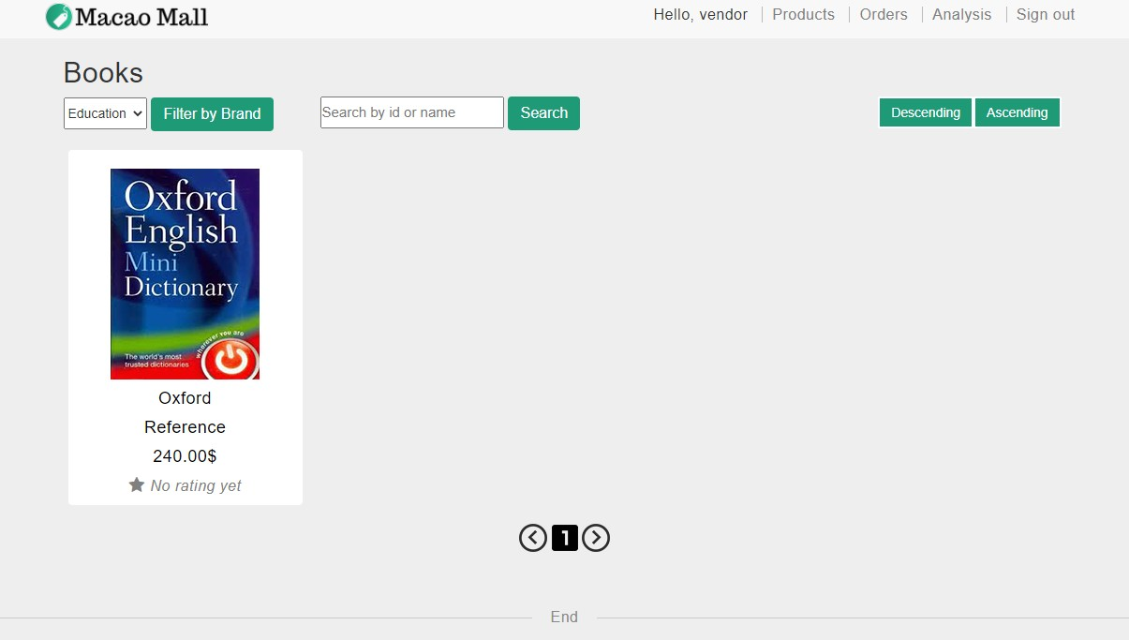

Vendor can search a product by product pid.

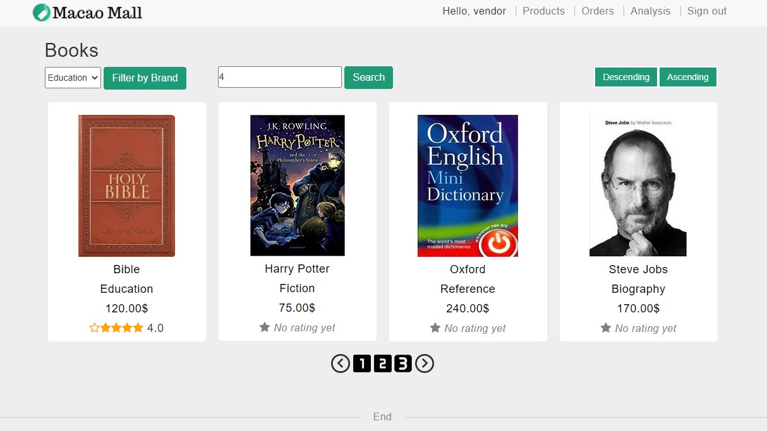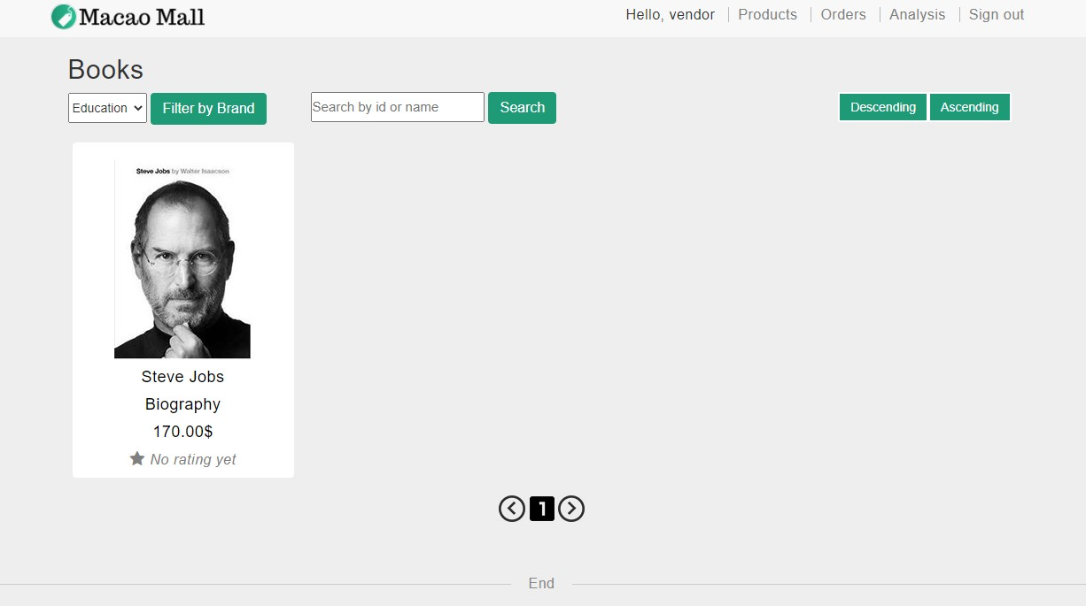

For a search that has no match, the page will display “Not Found”.

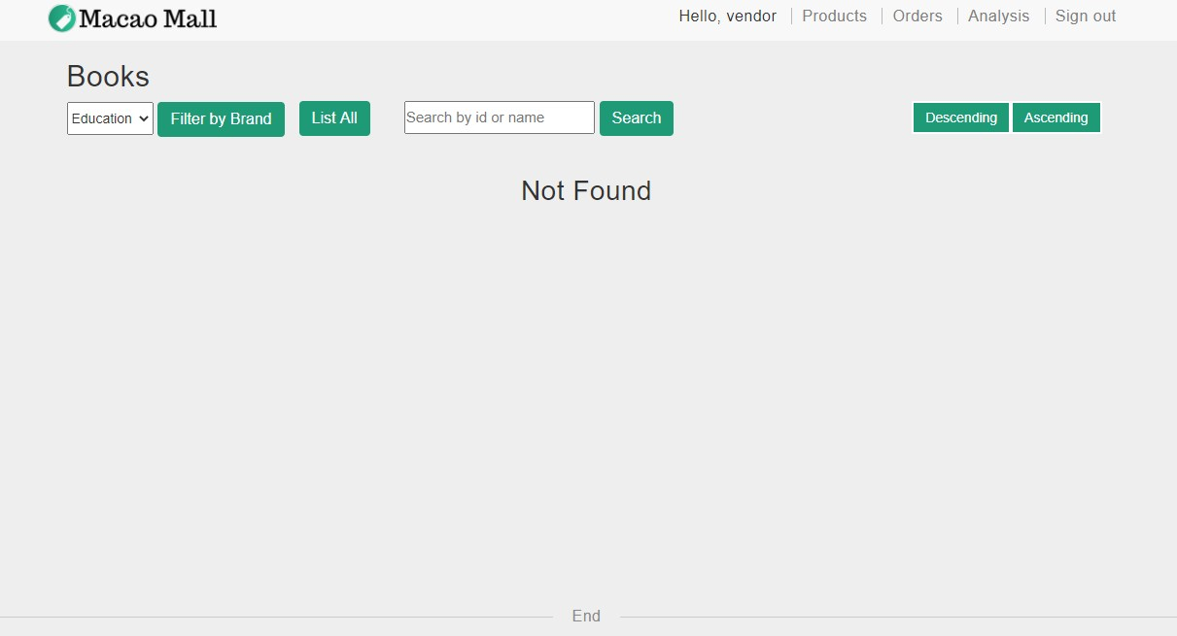

1. **Select a product and browse its details**

When logging into the vendor account, ‘add to cart’ button will be hidden.

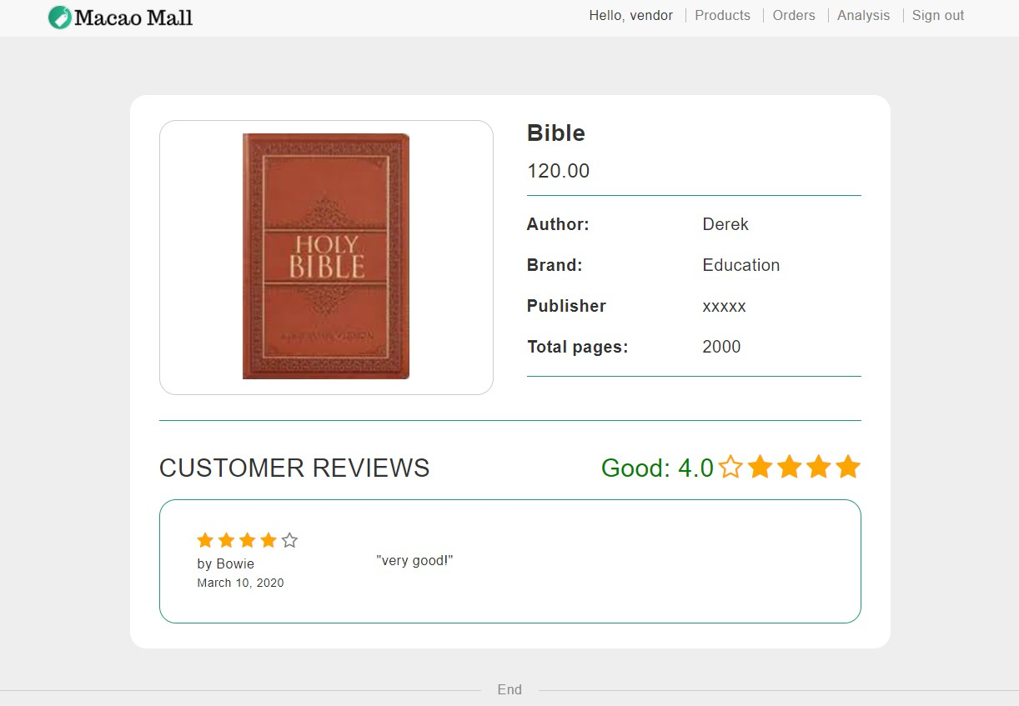

1. **Browse all the purchase orders in the purchase tracking page**

The purchase order list page lists all the purchase orders. It shows the P.O. numbers, purchase dates, customer names, total order amounts and purchase order status. The purchase orders are sorted in descending order of purchase date. The vendor can click the order number of ‘detail’ button on the right to open a purchase order processing page.

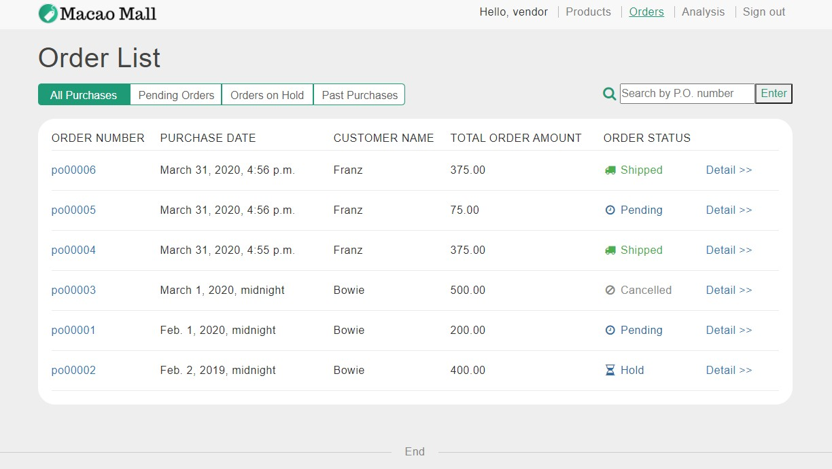

1. **Filter the purchase orders by pending, orders on hold and past orders**

The vendor can filter the purchase order list in three ways: the “pending orders”, or the “orders on hold”, or the “past orders”.

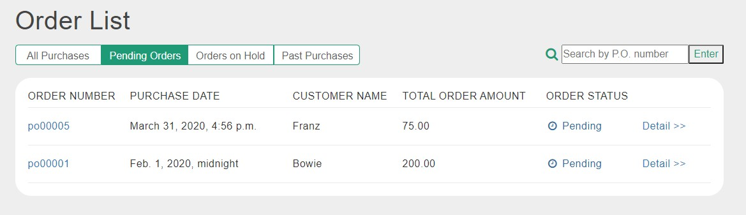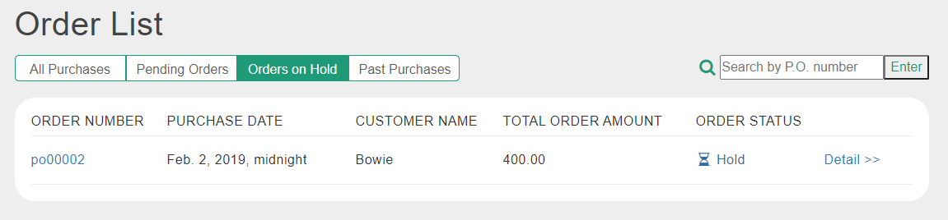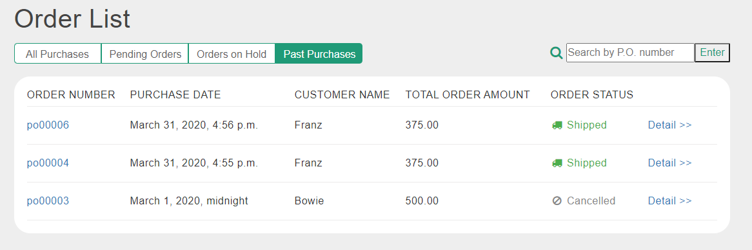

1. **Ship a purchase order**

The purchase order processing page shows all the information of an order and each product in the order. In addition, vendor can click the ‘ship this order’ to ship the order.

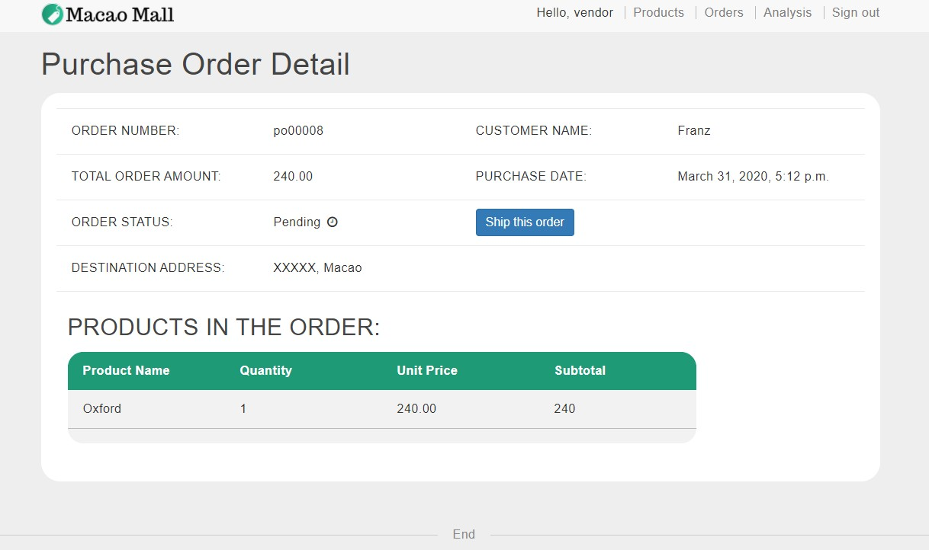

After clicking the “ship this order” button, the status of the order is changed to shipped, and a shipment date is displayed

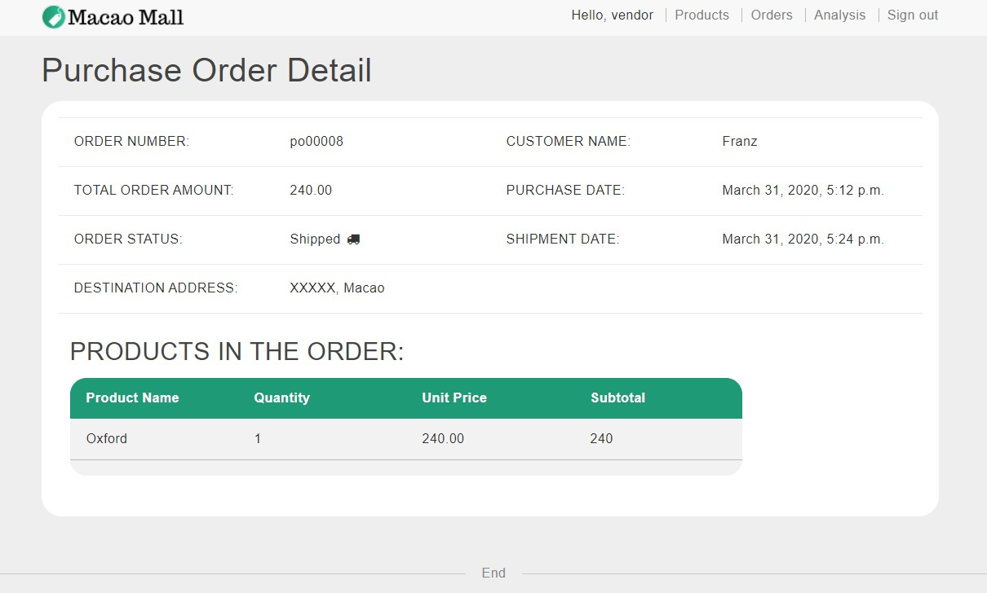

1. **Enter P.O. number to view and process the purchase order**

Vendor can search for a specific order by entering the order number.

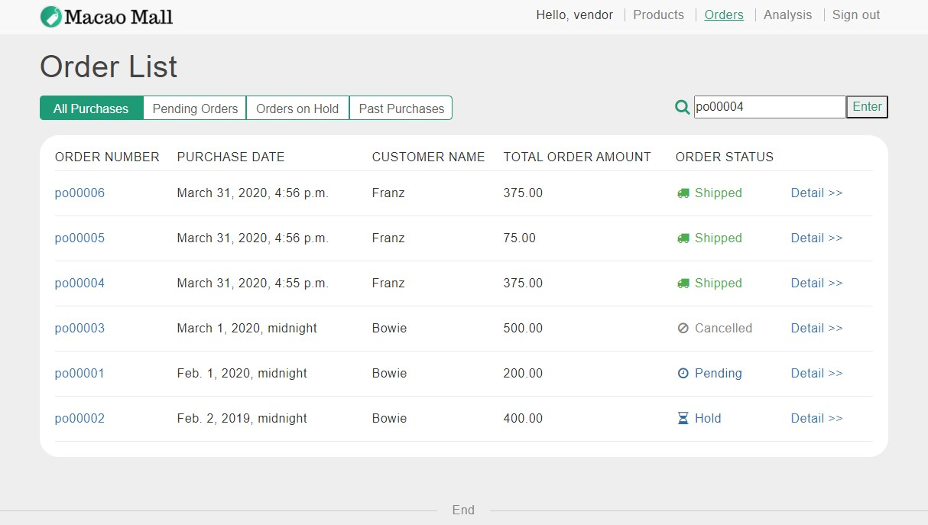

After entering an order number, vendor will be redirected to the order processing page of the order.

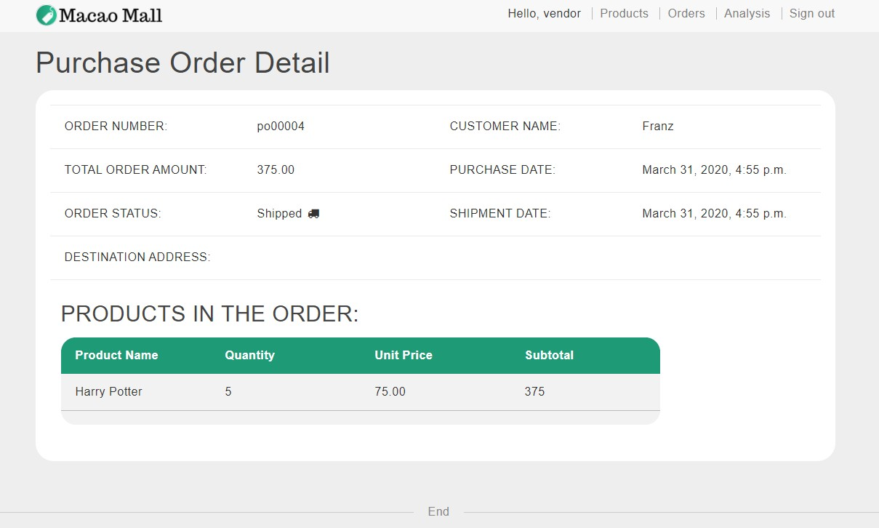

1. **Analysis report about sales amount and sales quantities**

When vendor logs in, there will be a button, “Analysis”, in the navigation bar. When clicking on this button, vendor can enter the analysis page. The default analysis is sales quantity. There are two major parts in this page, graph and list. In the graph, the x-axis is book name, and the y-axis is sales quantity. The graph only displays the top 8 products whose quantities are more than others. What’s more, the list will show all the products by descending order, according to the number of quantities.

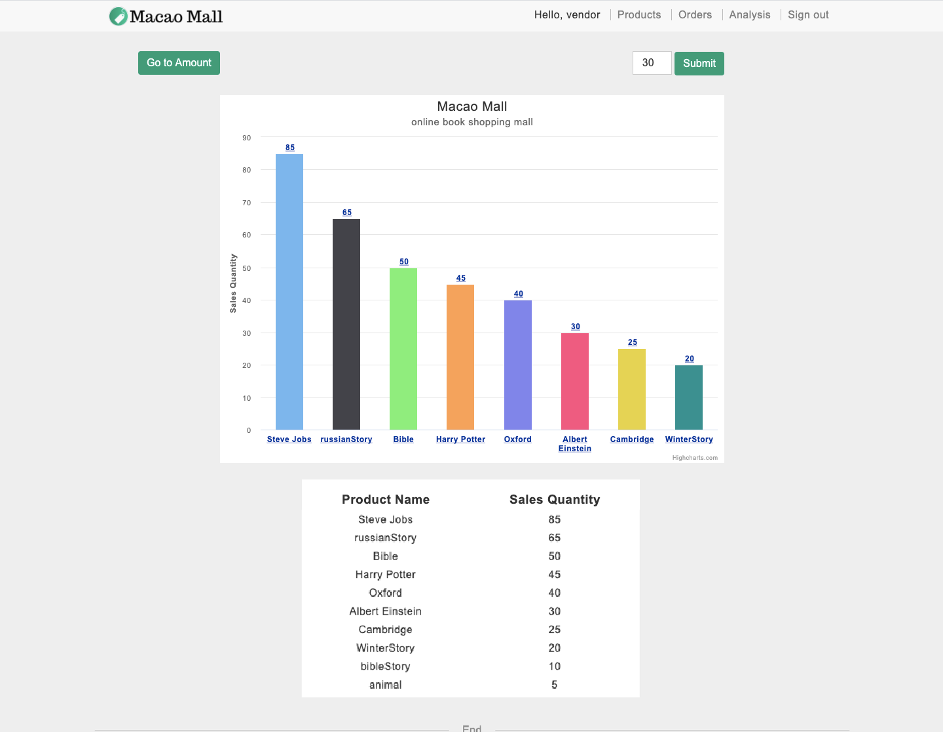

Move the cursor to the column, “Bible”, it will display the book name and sales quantity in big size.

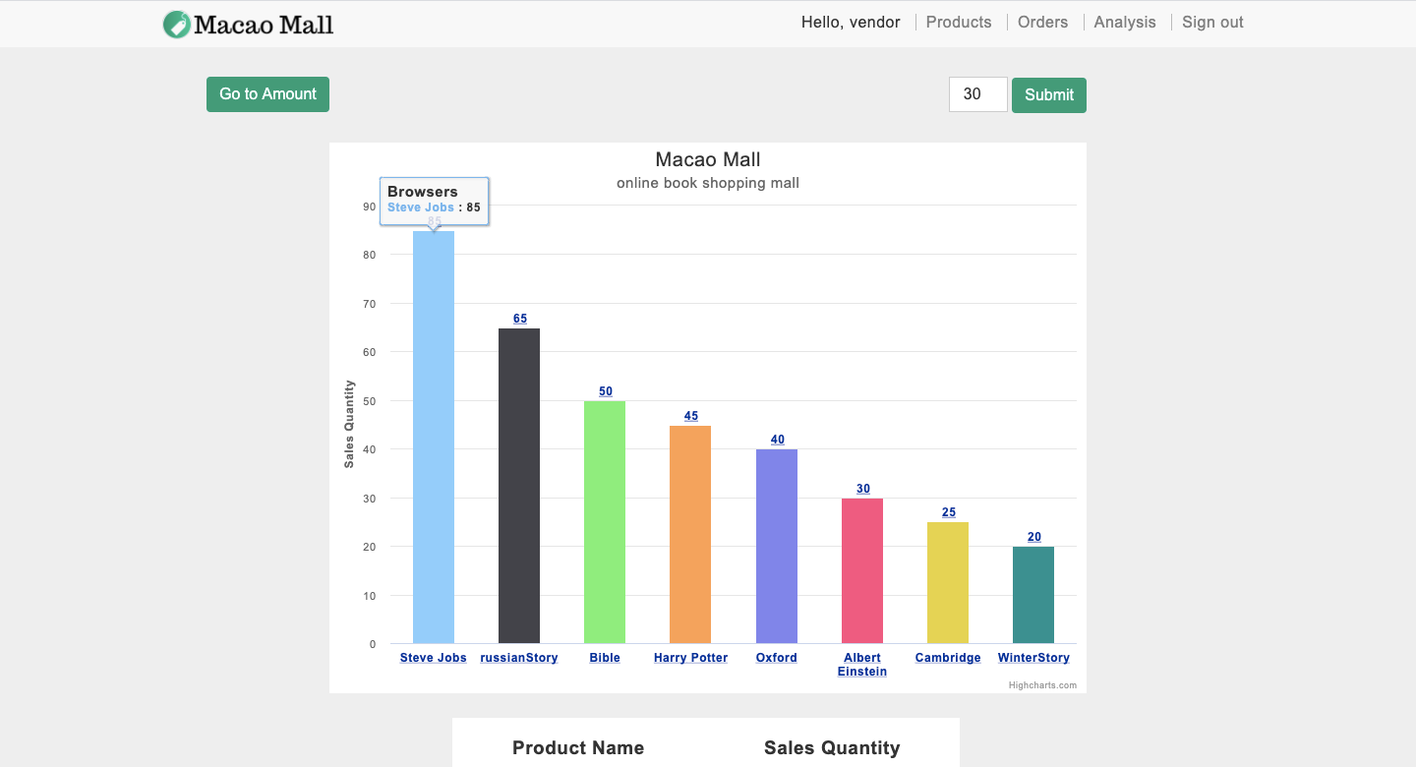

Input the number of days into the box and click on “submit” to customize the reporting period. The default days are 30. In this example, “100” is inputted in the box.

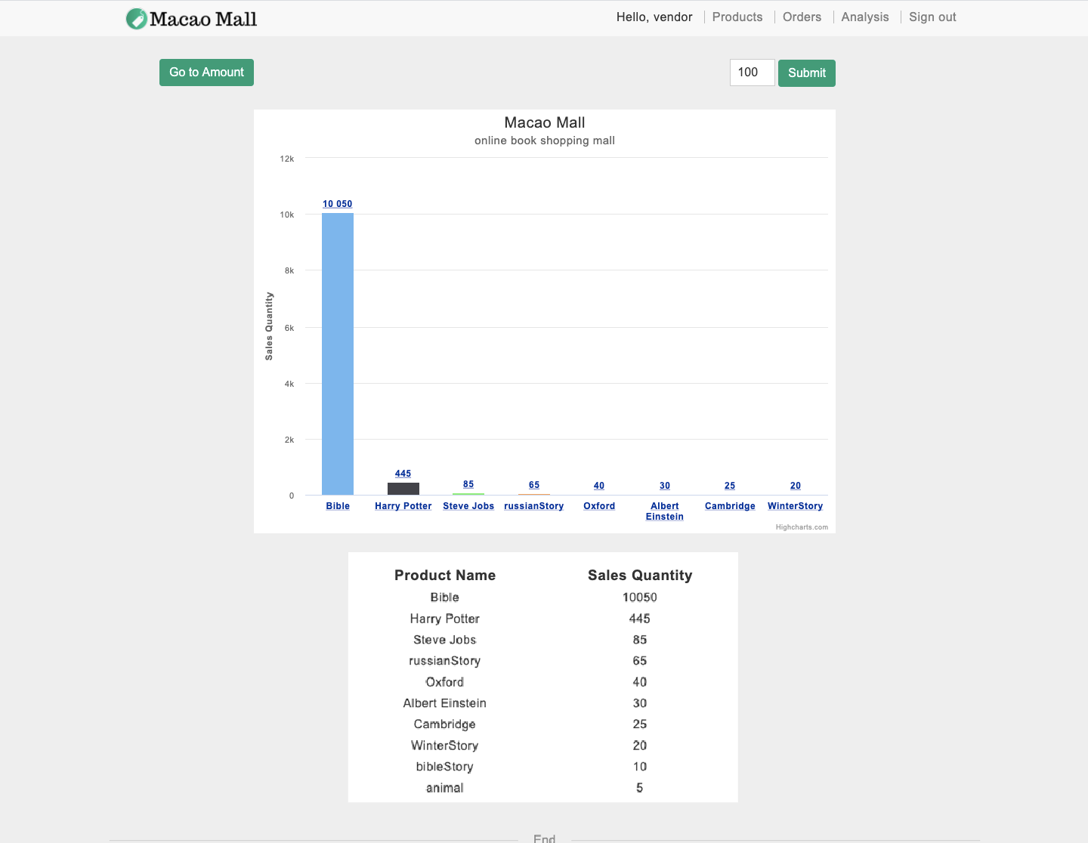

Click on the column and it will turn to another graph which includes the detail of the column. The x-axis is the date including day, month and year, and the y-axis is the sales quantity.

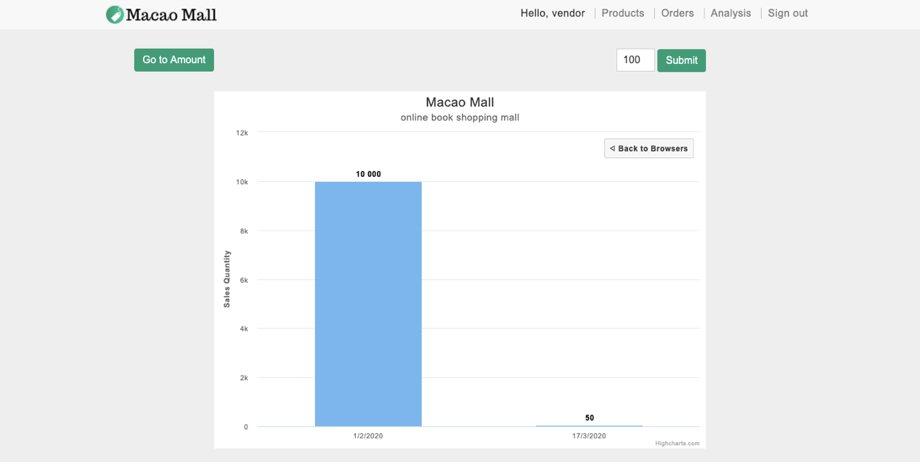

Click on the button, “Back to Browsers” and the graph will go back to the previous one.



Vendors can click on the button, “Go to Amount”, to enter the analysis of sales amount. There are two major parts in this page, graph and list. In the graph, the x-axis is book name, and the y-axis is sales amount. The graph only displays the top 8 products whose amounts are more than others. What’s more, the list will show all the products by descending order, according to the number of amounts.

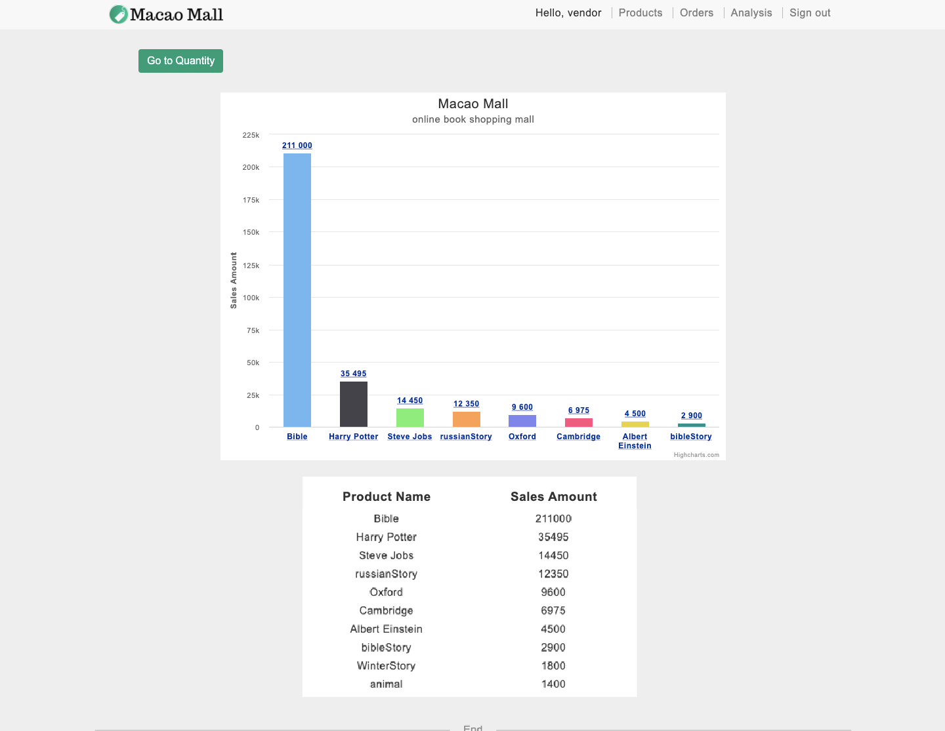

Click on the column and it will turn to another graph which includes the detail of the column. The x-axis is the date including day, month and year. And the y-axis is the sales amount.

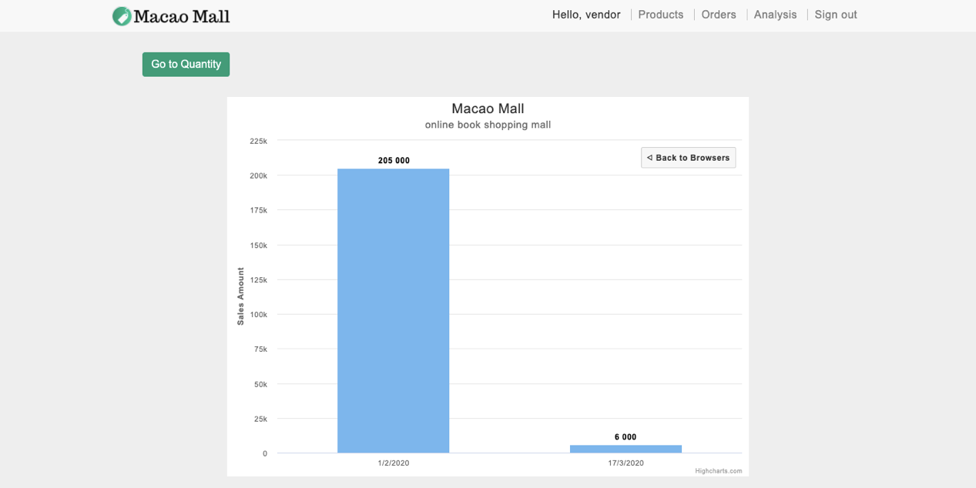

Click on the button, “Back to Browsers” and the graph will go back to the previous one.



Click on the button, “Go to Quantity” and it will go back to the graph of the analysis of sales quantity.

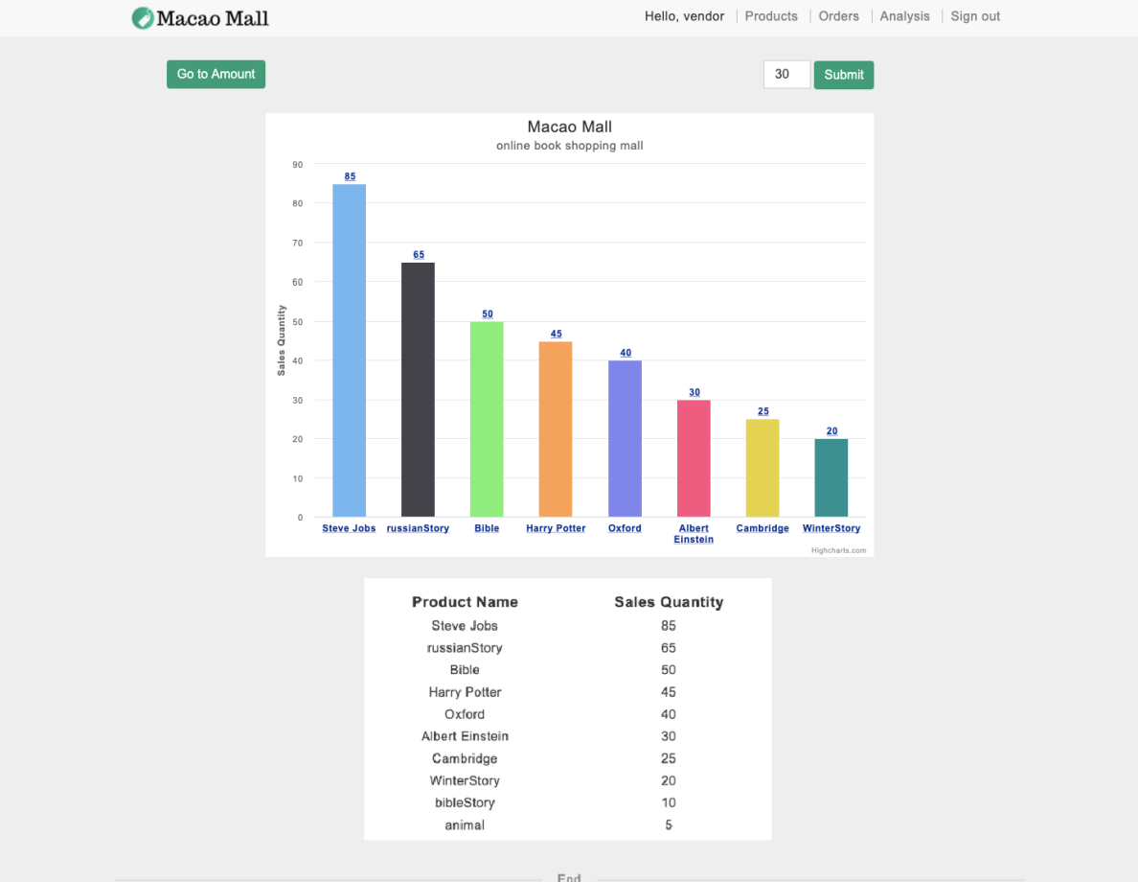

## Testing and System Evaluations

|  |  |  |  |  |
| --- | --- | --- | --- | --- |
|  | **Test Scenario** | **Test Detail** | **Expected Results** | **Pass/Fail** |
| TC01 | User login with valid data | Go to the login page and input valid ID and correct password | Login successful and be redirected to product page | Pass |
| TC02 | User login with invalid date | Go to the login page and input invalid ID and password | An error message appears and shows ‘Incorrect login information’ and the page is redirected to the login page | Pass |
| TC03 | User filters products by brand | Go to the product list page. Then select ‘Fiction’ type and click ‘Filter by brand’ button | The page only shows product in ‘Fiction’ type | Pass |
| TC04 | User sorts the product list by price | Go to the product list page and click ‘Descending’ button | The products are displayed in descending order of price | Pass |
| TC05 | User adds a product to the cart | Go to the product detail page of ‘Bible’ and click ‘add-to-cart’ button | The ‘add-to-cart’ turn to ‘already-in-cart’ and ‘Bible’ is in cart | Pass |
| TC06 | User changes the quantity of a product | Go to the cart page and change the quantity of ‘Bible’ to 2, then click ‘update’ button | The quantity of ‘Bible’ become 2 | Pass |
| TC07 | User checks out | Go to the cart page and click ‘checkout’ button | User is redirected to the order detail page of the newly created order | Pass |

|  |  |  |  |  |
| --- | --- | --- | --- | --- |
| TC08 | User writes a rating and a review to a product in an order | Go to the order detail page of ‘po00004’ and rate ‘Bible’ to 5 stars and write a review. Then click ‘POST’ button | ‘Write review’ button turn to ‘Edit review’. The rating and review are posted and display on the product detail page of ‘Bible’ | Pass |
| TC09 | User writes a review without rating | Go to the order detail page of ‘po00004’ and only write a review. Then click ‘POST’ button | An error message appears between the button and shows ‘You need to fill rating!’ | Pass |
| TC10 | User edits a review and a rating | Go to the order detail page of ‘po00004’ and change the rating ‘Bible’ to 4 stars and modify the review. Then click ‘UPDATE’ button | The rating and review are modified. On the product detail page of ‘Bible’, the edit time of this review is shown | Pass |
| TC11 | Vendor searches a product by product id | Log in as a vendor and go to the product list page. Enter ‘1’ to the search field then click ‘Search’ button | The page only shows ‘Bible’ which is with the product id ‘1’ | Pass |
| TC12 | Vendor searches a product by product id that is not exist | Log in as a vendor and go to the product list page. Enter ‘99 to the search field then click ‘Search’ button | The page shows ‘Not Found’ | Pass |
| TC13 | Vendor searches an order by order number | Log in as a vendor and go to the order tracking page. Enter ‘po00001’ to the search field then click ‘Enter’ button | The page jumps to the order detail page of the order ‘po00001’ | Pass |

|  |  |  |  |  |
| --- | --- | --- | --- | --- |
| TC14 | Vendor searches an order by order number that is not exist | Log in as a vendor and go to the order tracking page. Enter ‘po99999’ to the search field then click ‘Enter’ button | An error message appears and shows ‘Order does not exist’. Then the page is redirected to the order tracking page | Pass |
| TC15 | Vendor ships an order | Log in as a vendor and go to the order detail page of the order ‘po00001’. Then click ‘Ship this order’ button | The order is shipped and the shipment date is shown on the page | Pass |
| TC16 | Vendor changes analysis period | Log in as a vendor and go to the analysis page. Change the period to 7. | The page only shows the sales statistics in the last 7 days | Pass |

We shared 13 days to make this report. Franz Fang is in charge of cart, jack is in charge of Sign in, Tom is in charge of orders, and Ken is in charge of product

**Further Work**

In conclusion, online book shopping mall, Macao Mall, has been developed to allow vendors to display their books that is easy for customers to select and make purchases. In the shopping mall, it provides a sequence of primary functions to improve customer shopping experience.

At present, Macao Mall can only be accessed through browser, which means there is no mobile app as front-end of Macao Mall. In the future, if there are more users accessing Macao Mall by mobile phone or require a mobile app, we will develop an app for users. Another limitation is that the system does not provide recommendation function now, due to the fact that there are not enough products and data for us to do analysis. In the future, after the variety of products is enriched and with enough data collected, we will add a recommendation function to increase the possibility that users can find what they want.